BabyHelper AI



Ihsan Ullah Khan (Rc-423)
Tayyab Khalid (Rc-445)
Mir M. Zeeshan (Rc-431)

Supervised By
Sir Emad Amjad
Submitted for the partial fulfillment of BS Computer Science
degree to the Faculty of Engineering & CS

NATIONAL UNIVERSITY OF MODERN LANGUAGES, Rawalpindi
June, 2026
ABSTRACT
Parenting infants is a complex and demanding responsibility, often accompanied by
significant stress, sleep deprivation, and uncertainty regarding the infant's needs. In
Pakistan, the transition from joint to nuclear family structures has left many new
parents without traditional intergenerational support, which leads to parental
anxiety and potentially impact the infant's long-term development.

BabyHelper AI, aims to address these challenges by developing an integrated
mobile health application that serves as an intelligent assistant for infant
care. This app unifies four critical domains—cry analysis, growth tracking, nutrition
guidance, and sleep monitoring—into a single, cohesive platform.

AI-Powered Cry Analysis: Utilizing a YAMNet Embeddings + Optimized Classifier to classify infant cries into categories such as Hunger, Pain, Bally Pain, Discomfort and Tired with high accuracy. Integrating WHO Child Growth Standards to automatically calculate z-scores, providing early warnings for developmental deviations like stunting or obesity. Offering age-appropriate meal plans and recipes to combat malnutrition rooted in inappropriate complementary feeding. Leveraging TensorFlow Lite to execute all AI processing locally on the smartphone, ensuring user privacy and functionality without continuous internet access.

By providing objective, data-driven insights in a private and accessible format,
BabyHelper AI aims to reduce parental stress and provide access to standard
pediatric monitoring tools, bridging the gap between professional healthcare
guidelines and daily home care.

CERTIFICATE

Dated: __________

FINAL APPROVAL

It is certified that project report titled ‘BabyHelper AI’ submitted by Ihsan Ullah Khan, Tayyab Khalid and Mir M. Zeeshan for the partial fulfillment of the requirement of “Bachelor’s Degree in Computer Science” is approved.

COMMITTEE

Dr. Junaid Tariq
HoD Engineering Signature:

Ms. Sobia Shafiq
Project Coordinator Signature:

Mr. Emad Amjad
Supervisor Signature:

DECLARATION

We hereby declare that our dissertation is entirely our work and genuine / original. We understand that in case of discovery of any PLAGIARISM at any stage, our group will be assigned an F (FAIL) grade and it may result in withdrawal of our Bachelor’s degree.

Group members:

Name Signature

Ihsan Ullah Khan

Tayyab Khalid

Mir M. Zeeshan

PLAIGRISM CERTIFICATE

This is to certify that the project entitled “BabyHelper AI”, which is being submitted here with for the award of the “Degree of Bachelor’s in Computer Science”. This is the result of the original work by Ihsan Ullah Khan, Tayyab Khalid and Mir M. Zeeshan under my supervision and guidance. The work embodied in this project has not been done earlier for the basis of award of any degree or compatible certificate or similar tile of this for any other diploma/examining body or university to the best of my knowledge and belief.

Turnitin Originality Report
Processed on Jul 26, 2026, 9:32 PM GMT+5
ID: 3617492519
Word Count: 15,398

Similarity Index | 4%
Internet Sources: | 3%
Publications: | 2%
Student Papers: | 2%

Date: 01/07/2026 Mr. Emad Amjad (Supervisor)

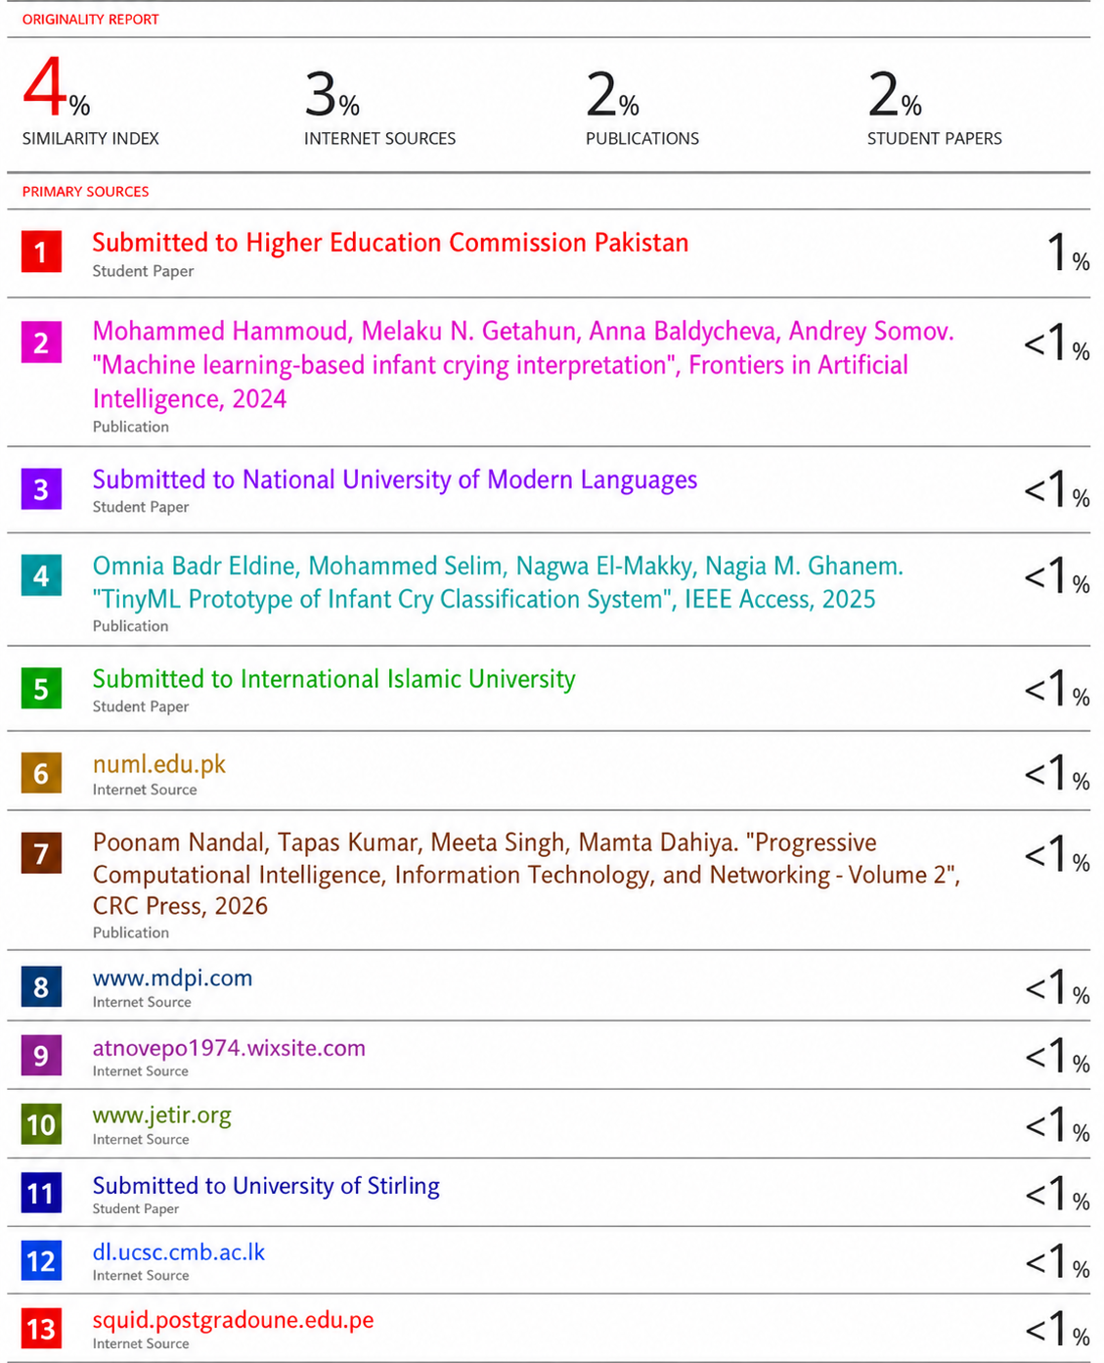
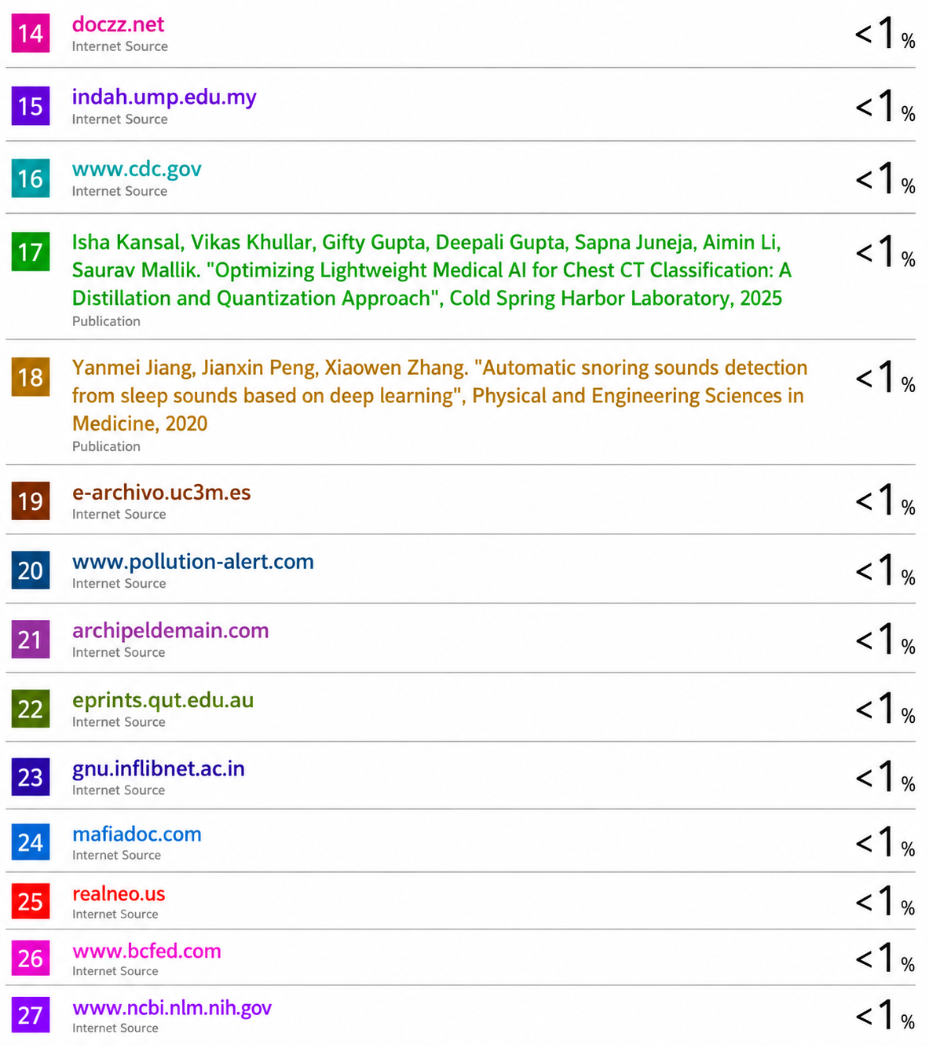
Table of Contents

CHAPTER PAGES

Chapter 1 1
1.1 Introduction 2
1.2 Motivation 2
1.3 Problem Statement 3
1.4 Goals and Objectives 3
1.5 Scope of the Study 4
1.6 Process Model 4
1.7 Nature of the Project 4
1.8 Report Organization: 5
Chapter 2 6
2.1. Introduction 7
2.2 Explanation of Important Constructs of the Application Domain 7
2.2.1 Mobile Health (mHealth) Applications 7
2.2.2 On-Device Machine Learning 8
2.2.3 Infant Cry Analysis 8
2.2.4 WHO Child Growth Standards 8
2.2.5 Infant Nutrition and Complementary Feeding 9
2.2.6 Infant Sleep Patterns 9
2.3. Existing studies/systems 10
2.3.1 Existing Studies 10
2.3.2 Existing Systems 14
2.4 Comparison of existing systems 15
2.4.1. Identified Problems from Existing Work 17
2.4.2. Solution for Existing System 17
2.5. Summary 18
Chapter 3 19
3.1 Introduction 20
3.2 Interface Requirements 20
3.2.1 Hardware Interface Requirements 20
3.2.2 Software Interface Requirements 20
3.3 Functional Requirements 21
3.4 Use Case Model 21
3.5 Use Cases 23
3.5.1 Use Case 1: User Registration and Login 23
3.5.2 Use Case 2: Record and Analyze Cry 23
3.5.3 Use Case 3: View Growth Measurement 23
3.5.4 Use Case 4: Log Meal / Generate Meal Plan 23
3.5.5 Use Case 5: Log Sleep Session 23
3.6 Non-Functional Requirements 24
3.6.1 Performance 24
3.6.2 Reliability 24
3.6.3 Security 24
3.6.4 Consistency 24
3.7 Resource Requirements 25
3.8 Database Requirements 25
3.9 Project Feasibility 25
3.9.1 Technical Feasibility 25
3.9.2 Operational Feasibility 26
3.9.3 Legal and Ethical Feasibility 26
3.10 Summary 26
Chapter 4 27
4.1 Introduction 28
4.2 System Design 28
4.3 Design Approach 28
4.4 Interface Design 29
4.5 4+1 View Model of Architecture 30
4.5.1 Logical View (Class Diagram) 31
4.5.2 Process View (Activity, State, and Sequence Diagrams) 31
4.5.3 Development View (Component Diagram) 36
4.5.4 Physical View (Deployment Diagram) 37
4.7 Summary 38
Chapter 5 39
5.1 Introduction 40
5.2 Modules of the Project 40
5.2.1 Cry Analyzer Module 40
5.2.2 Growth Tracker Module 40
5.2.3 Nutrition Guide Module 41
5.2.4 Sleep Monitor Module 41
5.3 System Workflow Summary 42
5.4 Summary 42
Chapter 6 43
6.1 Introduction 44
6.2 Testing Setup and Environment 44
6.2.1 Hardware and software Environment 44
6.2.2 Testing Methodology 45
6.3 Functional Testing 45
6.3.1 Authentication Module 45
6.3.2 User Interface and User Experience Testing 47
6.3.3 Cry Analyzer Module 49
6.3.4 Growth Tracker Module 51
6.3.4 Nutrition Guide Module 53
6.3.4 Sleep Monitor Module 55
6.5 Firebase Integration Testing 57
6.5.1 Firestore Database Operations 57
6.6 Performance Testing 60
6.6.1 App Performance Metrics 60
6.8 Overall Results Summary 60
6.8 Cross-Platform Compatibility 61
6.9 Known Limitations 61
6.10 Summary 62
Chapter 7 63
7.1 Introduction 64
7.2 Review Against Proposed Objectives 64
7.2.1 Objectives Comparison 64
7.2.2 Additional Features Built 65
7.2.2.1 Silence Detection 65
7.2.2.2 Centralized Dashboard with AI Tips 65
7.2.2.3 Multi-Baby Support 65
7.2.2.4 Baby Profile Management 65
7.3 Key Achievements 66
7.3.1 On-device AI inference 66
7.3.2 WHO-standard growth assessment 66
7.3.3 Complete data persistence 66
7.3.4 Age-adaptive nutrition system 66
7.4 Limitations 67
7.4.1 Cry Analyzer Limitations 67
7.4.2 Growth Tracker Limitations 67
7.4.3 Nutrition Guide Limitations 67
7.4.4 Sleep Monitor Limitations 68
7.4.5 General Limitations 68
7.5 Future Recommendations 68
7.5.1 Improve Cry Classification Accuracy 68
7.5.2 Extend Growth Standards Beyond 24 Months 68
7.5.3 Build a Dynamic Recipe Backend 69
7.5.4 Add Automatic Sleep Tracking 69
7.5.5 Add Push Notifications and Reminders 69
7.5.6 Support iOS Platform 69
7.5.7 Add Data Export and Sharing 70
7.6 Summary 70
REFERENCES 71

List of Figures

Figure 3.1: Use Case Diagram Main 22
Figure 3.1 Use Case Diagram Parent 22
Figure 4.1 : Class Diagram 31
Figure 4.2: Activity Diagram 33
Figure 4.3: State Diagram 43
Figure 4.4.1: Sequence Diagram 35
Figure 4.4.2: Sequence Diagram 36
Figure 4.5: Component Diagram 37
Figure 4.6: Deployment Diagram 38

List of Tables

Table 2.1: Comparison of existing studies 15
Table 2.2: Comparison of existing systems 16
Table 6.1: Hardware and Software Environment 44
Table 6.2: Authentication Module 45
Table 6.3: UI/UX Testing 47
Table 6.4: Cry Analyzer Module 49
Table 6.5: Growth Tracker Module 51
Table 6.6: Nutrition Guide Module 53
Table 6.7: Sleep Monitor Module 55
Table 6.8: Firestore Database Operations 57
Table 6.9: App Performance Metrics 60
Table 6.10: Overall Result 60
Table 6.11: Cross Platform Compatibility 61
Table 7.1: Objectives Comparison 64

Chapter 1
INTRODUCTION

1.1 Introduction
Parenting infants is a demanding and multifaceted responsibility that requires constant physiological and emotional adaptation from caregivers. In Pakistan, the rapid shift from joint family systems to nuclear family units has left many new parents without the traditional intergenerational support network that previously assisted in child-rearing. This isolation is particularly acute in urban environments, where parents struggle to interpret their infant's non-verbal distress signals, monitor growth milestones, and ensure adequate nutrition without immediate guidance. The resulting parental anxiety is a significant public health concern, research indicates that the inability to accurately interpret infant needs can lead to moderate to severe stress, potentially affecting the parent-child bond and the infant’s long-term development [1] [2].
BabyHelper AI addresses these challenges by introducing an intelligent, integrated mobile health (mHealth) solution. Unlike existing fragmented tools that focus on single aspects of care, this system unifies four critical domains—cry analysis, growth tracking, nutrition, and sleep monitoring—into a single, cohesive platform. By leveraging Artificial Intelligence and Machine Learning directly on the user's device, the system provides real-time, context-aware decision support. It bridges the gap between professional pediatric standards and daily home care, empowering parents with data-driven insights to make informed decisions about their infants well-being.

1.2 Motivation
The primary motivation for this project stems from the critical gap between recommended pediatric guidelines and actual practices observed in Pakistani households. Malnutrition and stunting remain prevalent issues in Pakistan, often driven by inappropriate complementary feeding practices rather than food scarcity alone, with studies in Lahore revealing significant gaps in maternal knowledge regarding infant meal consistency, frequency, and diversity. BabyHelper AI addresses this by providing culturally adapted nutritional guidance that integrates traditional Pakistani foods (e.g., Khichdi, Dalia) with WHO nutritional standards, a strategy validated by similar mHealth interventions in developing nations. Additionally, manual tracking of growth parameters is prone to human error, whereas research on the GROWIN app demonstrated that digital, automated growth monitoring significantly improves early detection of growth disorders compared to traditional paper charts. Furthermore, the inability to interpret infant cries is a leading cause of parental exhaustion and postpartum anxiety; by offering an objective, AI-based assessment of whether a cry indicates pain, hunger, or discomfort, the system aims to reduce caregiver stress and prevent unnecessary medical visits.

1.3 Problem Statement
Currently, Pakistani parents lack a unified, scientifically validated tool to assist with holistic infant care. The existing landscape of digital parenting tools suffers from three critical flaws. Parents must use separate apps for sleep tracking, growth logging, and cry detection, leading to disjointed data and "app fatigue". Existing growth tracking relies on manual interpretation of complex WHO percentiles, leading to missed diagnoses of developmental delays. Similarly, cry interpretation is currently subjective; apps like ChatterBaby rely on manual parental labeling rather than objective multimodal data, leading to potential misinterpretation of pain cues. Most available nutrition apps offer Western meal plans unavailable or culturally irrelevant to the average Pakistani household, leading to low adherence. BabyHelper AI solves these problems by integrating all four modules into a single application that uses localized content and advanced AI architectures to ensure robustness and relevance.

1.4 Goals and Objectives
We will develop an intelligent, easy-to-use mobile application that assists parents in monitoring and managing their infant’s health and daily care needs through AI-powered cry analysis, WHO-standard growth tracking, age-adaptive nutrition planning, and sleep pattern monitoring. Following are the objectives:
- To develop a cry classification system that uses a TensorFlow Lite model to identify the reason behind a baby’s cry from a short audio recording, with a fallback audio feature analysis method for reliability.
- To implement a growth tracking module that calculates z-scores using the WHO LMS method with embedded reference tables for both male and female infants aged 0 to 24 months.
- To build a nutrition guide that provides age-appropriate recipes and generates weekly meal plans while respecting the baby’s allergen profile.
- To create a sleep monitoring module that logs sleep sessions, calculates daily and weekly statistics, and provides age-based sleep recommendations.

1.5 Scope of the Study
This project focuses on building an Android app using Flutter. Its main feature is a cry analyzer that uses a built-in AI model to sort cries into five categories; if the AI isn't available, it uses a backup method that analyzes the sound directly. We are also including a growth tracker that calculates official WHO health scores for babies up to two years old. For feeding, the app comes with 12 built-in recipes and can automatically create a 7-day meal plan while filtering out foods the baby is allergic to. There is also a sleep tracker with daily stats, weekly trends, and helpful tips. Parents can log in securely with their email or Google account, save their data safely in the cloud for offline access, and manage profiles for more than one baby. Finally, all of this information comes together on a single, easy-to-read dashboard.

1.6 Process Model
For BabyHelper AI, we chose the Agile process model, which focuses on building the app in short, repeating cycles. Instead of planning everything upfront, we build, test, and refine a working piece of the app in each cycle. For example, we originally only used the AI model for cry analysis, but later realized it could fail to load on certain phones. Because we use Agile, we could easily add a backup audio analysis method without messing up our whole plan. Second, the app naturally breaks down into four independent modules such as Cry, Growth, Nutrition, and Sleep, so it made sense to tackle each one in its own cycle. We started with the login and dashboard, then added the features one by one.

1.7 Nature of the Project
BabyHelper AI is an AI-powered mobile health application that falls at the intersection of three technology domains. Artificial Intelligence, Cry Analyzer, which uses a TensorFlow Lite model to classify baby cries on-device. The growth tracker uses the WHO LMS statistical method to compute z-scores. Mobile Application Development, the application is built as a native Android app using the Flutter framework. It uses modern mobile development practices. Cloud Computing, the application uses Firebase as its cloud backend for user authentication (Firebase Auth) and data storage (Cloud Firestore). The project demonstrates how AI and cloud technologies can be combined in a mobile application to solve a real-world problem helping parents understand and respond to their baby’s needs more effectively.

1.8 Report Organization:
This report is organized into seven chapters to walk you through how we built BabyHelper AI. We start in Chapter 1 by introducing the project, the problem we're solving, and our goals. Chapter 2 dives into the background, covering the science of infant care and looking at other apps to see what they missed. Chapter 3 lays out all the requirements—what hardware and software we needed, the specific features we planned, and whether the project was actually feasible. Moving into Chapter 4, we get into the system design, showing how the app is structured using various diagrams and mapping out the user interface. Chapter 5 explains the actual coding and implementation, breaking down how each module works, like the AI cry analysis and the WHO growth math. Chapter 6 is where we test everything; we ran 52 tests and talk honestly about how the app performed and where it falls short. Finally, Chapter 7 wraps it up by looking at what we achieved, the specific limitations we faced, and where the app could go in the future.

Chapter 2
BACKGROUND AND EXISTING SYSTEMS

2.1. Introduction
This chapter provides the theoretical foundation and critical analysis of existing literature necessary to understand the development of BabyHelper AI. It begins by explaining the core constructs of the application domain, including the physics of infant acoustics, the medical standards for growth monitoring, and the computational frameworks used in mobile health interventions. Subsequently, it presents a detailed review of significant recent studies that utilize Artificial Intelligence (AI) for infant care, analyzing their methodologies, strengths, and limitations. The purpose of this chapter is to show that the project is grounded in established scientific knowledge and addresses a real need that is not fully met by current solutions.

2.2 Explanation of Important Constructs of the Application Domain
Developing an effective AI-powered infant care solution like BabyHelper AI requires a deep understanding of several key domains. This includes infant development and common parental challenges, the principles of mobile health technology, and the artificial intelligence techniques that will power our core features. This section explains these concepts in detail to clarify the foundation of our project.

2.2.1 Mobile Health (mHealth) Applications
Mobile health, or mHealth, simply means using phones and apps to manage health and wellness. This area has exploded lately, covering everything from fitness and mental health to pregnancy and baby care. There are a few big reasons mHealth apps are so helpful. First, they are highly accessible since almost everyone already has a smartphone. Second, they allow for continuous monitoring; parents can log data throughout the day to see the big picture over time. Third, they offer personalization, giving advice tailored specifically to the user's own data, like a baby's age or health conditions. Finally, digital records make it incredibly easy to share information with a doctor during check-ups.

2.2.2 On-Device Machine Learning
Usually, machine learning apps send your data to a cloud server to be processed. On-device machine learning is different—it runs the AI model right on the user's phone. We use Google's TensorFlow Lite to do this in BabyHelper AI, and it has some massive benefits. The biggest one is privacy; the baby's cry audio never leaves the phone or gets uploaded anywhere. It's also much faster, giving results in under a second because there's no waiting for a network connection. Plus, it works entirely offline, and it saves money because we don't have to pay for expensive servers to run the AI. The trade-off is that on-device models have to be small and simple, which can mean they aren't as accurate as massive cloud models. Our cry analysis model is tinyand only 19 KB, it accurately classifies the cry about 55% to 65% of the time on clear recordings.

2.2.3 Infant Cry Analysis
Crying is a baby's main way to communicate. Research shows that different cries actually have different sound patterns. Priscilla Dunstan identified five universal baby sounds: a "Hungry" cry is rhythmic with a moderate pitch; a "Tired" cry is lower pitched and starts slowly; a "Belly Pain" cry is high-pitched and sharp; a "Discomfort" cry is irregular and moderate; and a "Burping" cry comes in short bursts with a nasal sound. We can measure these differences using audio features. RMS Energy measures loudness—high energy usually means pain, while low energy often means tiredness. Zero-Crossing Rate (ZCR) measures pitch; a higher rate points to a higher pitch, like with pain cries. Spectral Centroid measures if the cry sounds bright or dull. Today, machine learning models are much better at picking up on these subtle patterns than humans are. By using TensorFlow Lite, we can run these models right on the phone, which keeps the baby's audio completely private and off external servers.

2.2.4 WHO Child Growth Standards
To track growth, we use the WHO Child Growth Standards from 2006. These are based on a huge study of healthy kids from six countries and show how a healthy baby should grow under the best conditions. They use the LMS method, which looks at three things for a baby's specific age: "L" adjusts the data to fit a normal curve, "M" is the median (or average), and "S" is how spread out the numbers are. This gives us a z-score using the formula: z = ((measurement / M)^L - 1) / (L × S). A z-score of 0 means the baby is exactly average. A score of -2 means they are two standard deviations below average, which is a red flag. The WHO gives different tables for boys and girls, and for weight, height, and head size. Generally, a score between -2 and +2 is normal. Below -2 means underweight or stunted growth, and above +2 means overweight. Doctors worldwide rely on these numbers as the gold standard.

2.2.5 Infant Nutrition and Complementary Feeding
When it comes to feeding, the WHO says babies should only have breast milk for the first six months. After that, parents can start introducing solid foods while still breastfeeding up to two years or beyond. This transition happens in stages. From 6 to 7 months, babies eat smooth, single-ingredient purees 2 to 3 times a day. From 8 to 9 months, they move to mashed foods with soft lumps and eat 3 meals plus 1 snack. From 10 to 12 months, they can eat chopped-up family foods and have 3 meals plus 2 snacks. By 12 to 24 months, they can eat mostly what the family eats and feed themselves. Because allergies are common in foods like dairy, eggs, gluten, nuts, soy, and fish, doctors recommend introducing these one at a time. That way, if a baby has a bad reaction, parents know exactly which food caused it.

2.2.6 Infant Sleep Patterns
Sleep is incredibly important for a baby's brain and body to develop. The American Academy of Sleep Medicine gives clear guidelines on how much sleep kids need, and it changes fast as they grow. Newborns up to 3 months need 14 to 17 hours of sleep, which happens in lots of short naps and frequent night wakings. By 4 to 6 months, babies need 12 to 16 hours, and they start sleeping longer stretches at night with 2 to 3 daytime naps. From 7 to 12 months, they need 12 to 15 hours, usually with longer night sleep and 2 daytime naps. Toddlers between 1 and 2 years old need 11 to 14 hours, mostly sleeping through the night and dropping down to just one daytime nap. Things like room temperature, lighting, noise, and bedtime routines all affect how well a baby sleep. By tracking their baby's sleep, parents can spot these patterns and tweak their routines to help everyone rest better.

2.3. Existing studies/systems
The domain of infant care has seen significant progress with the integration of artificial intelligence and mobile health platforms. Researchers have explored various approaches, such as AI-powered cry analysis, developmental tracking systems, and personalized mobile applications, to support new parents and improve infant well-being.

2.3.1 Existing Studies
2.3.1.1 This study addressed the critical challenge of deploying sophisticated AI models on resource-constrained devices, which is a central requirement for mobile-based parenting tools. The researchers developed a lightweight deep learning model specifically designed for the rapid classification of infant cries on edge devices like the Raspberry Pi and ESP32. They utilized two primary datasets, "Baby Chillanto" and "Donate-a-Cry," to train a self-defined ResNet (Residual Network) architecture. The methodology involved extracting MFCCs as the primary feature set, optimizing them by varying frame lengths (finding 50ms to be optimal), and then applying post-training quantization to convert the model from 32-bit floating-point to 8-bit integers. The results were highly significant: the unquantized ResNet model achieved an accuracy of 96.26% on the Baby Chillanto dataset. After quantization, which reduced the model size to just 93 KB and RAM usage to under 30 KB, the accuracy remained robust at 94.71%. The system demonstrated a real-time inference speed of 3.44 milliseconds. This study provides the direct technical justification for the BabyHelper AI architecture, validating that a quantized model using MFCCs is feasible for a mobile application intended for users with mid-range smartphones in Pakistan [3].
2.3.1.2 This research paper focused on improving the accuracy of cry classification by moving beyond simple Convolutional Neural Networks (CNNs). The authors argued that while CNNs are excellent at recognizing spatial patterns in audio spectrograms, they often fail to capture temporal dependencies. To solve this, they proposed and evaluated a Hybrid Architecture combining CNNs with Long Short-Term Memory (LSTM) networks. Utilizing a dataset of infant cries categorized into hunger, pain, and discomfort, the methodology involved passing audio spectrograms through convolutional layers to extract high-level feature maps, which were then fed into LSTM layers. The findings were conclusive: the Hybrid CNN-LSTM model significantly outperformed standalone CNN and LSTM models, achieving classification accuracies as high as 99% in controlled tests. The study highlighted that the LSTM component was crucial for differentiating between cry types that share similar spectral features but have different rhythmic patterns. This literature is central to the BabyHelper AI project, dictating the selection of the CRNN architecture [4].
2.3.1.4 In this paper that we reviewed, the InfantCryNet is a novel framework for detecting and analyzing infant cries to help young parents understand their newborns' needs. The system addresses key challenges including background noise, limited labeled data, and mobile deployment requirements. The framework employs pre-trained audio models to overcome data scarcity and proposes statistical pooling and multi-head attention pooling techniques for effective feature extraction from audio clips. Using CNN architectures (CNN-10 for detection, CNN-14 for classification), the system can identify six distinct cry reasons: awake, hug, sleepy, uncomfortable, diaper, and hungry. Experiments demonstrate that InfantCryNet outperforms state-of-the-art baselines by 4.4% in classification accuracy. Knowledge distillation and model quantization enable efficient mobile deployment, reducing model size by 7% without accuracy loss or up to 28% with only 8% accuracy reduction. This makes the framework practical for real-world applications on smartphones and tablets [5].
2.3.1.5 In this study they presented a machine learning framework for interpreting infant cries to help caregivers understand newborns' needs. The research addresses challenges of background noise and limited labeled data by employing comprehensive feature extraction methods across multiple domains: time-domain features (zero-crossing rate and root mean square), frequency-domain features (Mel spectrogram), and time-frequency domain features (Mel frequency cepstral coefficients). The framework classifies infant cries into five categories: hunger, discomfort, belly pain, burping, and tiredness using the donate-a-cry-corpus dataset. Time-series imaging algorithms (GADF, GASF, MTF, RP, RGB GAF) transform MFCC features into images for enhanced representation. Various classifiers were evaluated including decision tree, random forest, K-nearest neighbors, SVM, and bagging. The MFCC-based random forest classifier achieved optimal performance with 96.39% accuracy, outperforming the state-of-the-art scalogram-based ShuffleNet (94.56% accuracy). Data augmentation addressed class imbalance, while grid search with 10-fold cross-validation optimized model parameters [6].
2.3.1.6 The paper shows they study evaluates the noise-robustness of Convolutional Neural Networks (CNNs) versus Recurrent Neural Networks (RNNs) for baby cry recognition in real-world environments. A novel CNN architecture featuring three convolutional layers, max pooling, and 0.5 dropout was proposed and compared against standard RNN models (GRU and LSTM) using the Madsaz Baby Cry Translator dataset containing 175 recordings across five cry categories (hunger, discomfort, belly pain, burping, tiredness). Models were trained for 100 epochs with batch size 64 and evaluated under clean and noisy conditions with varying signal-to-noise ratios (5-20 dB SNR). While both architectures achieved high accuracy (>89%) in noise-free environments, the CNN demonstrated superior noise-robustness, maintaining 93% precision and 91% overall accuracy under 10dB noise compared to RNN. This performance advantage stems from CNN's ability to extract spatial features from Mel spectrograms, making it less susceptible to noise disruptions. Among RNNs, GRU outperformed LSTM in noisy settings due to its simpler architecture and better noise handling [7].
2.3.1.7 In this study it shows a pioneering multi-modal analysis of infant crying, combining acoustic recordings, electroencephalography (EEG), near-infrared spectroscopy (NIRS), facial expressions, and body movements from 38 healthy full-term newborns. Five cry types were characterized: hunger, sleepiness, fussiness, need to burp, and distress. Statistical analysis revealed significant differences across cry types in all modalities. Machine Learning identified acoustic features and body language as the most relevant for cry classification. The Deep Learning Acoustic MultiStage Interpreter (AMSI) algorithm achieved 92% accuracy in cry type recognition. Results demonstrated that acoustic patterns correlate with distinct neurophysiological and behavioral signatures for each cry type. Hungry and distress cries showed higher urgency levels and brain activation, while sleepy and fussy cries indicated calmer states with different EEG patterns.This research establishes infant cry analysis as a promising, objective, non-invasive tool for interpreting newborn needs, potentially improving infant-parent relationships and supporting clinical assessment of infant well-being [8].
2.3.1.8 This study evaluated the clinical utility and feasibility of "GROWIN," a mobile health application designed to automate the detection of growth disorders in children. The researchers conducted a massive retrospective analysis of data collected from over 21,000 users over three years (2018–2020). The app processed user-inputted anthropometric data using algorithms based on WHO and CDC growth standards. The results provided strong validation for the digitization of growth monitoring. The app successfully identified 1,750 children with abnormal growth patterns and triggered automated recommendations. Crucially, for children identified with obesity, the app's intervention resulted in a statistically significant decrease in Body Mass Index (BMI) scores after 3-6 months of use. This study confirms that mobile applications are active interventional tools, supporting the BabyHelper AI problem statement that manual growth tracking is insufficient and validating the inclusion of an automated Growth Tracking Module [9].
2.3.1.9 This paper explored the effectiveness of mHealth interventions in a developing nation context, specifically targeting teenage mothers in Nigeria to improve Infant and Young Child Feeding (IYCF) practices. The researchers developed "BabyThrive," an offline mobile gaming app that educated mothers on exclusive breastfeeding and complementary feeding. Using a crossover design with 90 participants, the study found that mothers who used the app showed a 12-fold increase in nutritional knowledge scores compared to their pre-training baseline. The app was found to be 1.29 times more effective than verbal training by health workers. The study proved that digital tools are highly acceptable even in rural, low-income settings and that "gamified" content leads to better retention of nutritional guidelines. This directly supports the design of the Nutrition Guide Module in BabyHelper AI [10].

2.3.2 Existing Systems
2.3.2.1 ChatterBaby is a prominent mobile application designed to translate infant cries for parents, primarily focusing on distinguishing pain cries from fussiness or hunger. It utilizes acoustic feature extraction and machine learning algorithms trained on a dataset of labeled cries. While effective in its specific domain, ChatterBaby relies heavily on manual labeling by parents for its ground truth data, which introduces subjectivity. Furthermore, it operates as a standalone tool without integration into broader health metrics like growth or nutrition, limiting its utility as a comprehensive care platform [11].
2.3.2.2 GROWIN app focuses exclusively on the monitoring of child growth. It allows parents to input weight and height data, which the system then compares against WHO and CDC growth curves to detect deviations such as obesity or stunting. While highly accurate and clinically validated, GROWIN lacks any behavioral analysis features. It does not interpret why a child might be failing to grow (e.g., poor sleep or feeding issues), leaving a gap in holistic care [9].
2.3.2.3 Nenne Navi is a sleep-focused application developed in Japan. It employs a "Plan-Do-Check-Act" cycle where parents log sleep data, and the system provides advice to improve sleep hygiene. While effective for sleep consolidation, the system is not fully automated; it often requires manual intervention or review by experts to provide personalized advice. This reliance on human-in-the-loop processing makes it difficult to scale to a large population like Pakistan's without significant resources [12].
2.3.2.4 BabyThrive is an educational mobile game designed to improve nutritional knowledge among mothers in Nigeria. It uses gamification to teach breastfeeding and complementary feeding practices. While excellent for education, it is not a monitoring tool; it does not track real-time physiological data like weight gain or sleep duration. It addresses the "knowledge gap" but does not provide the "tracking tools" necessary for daily management [10].

2.4 Comparison of existing systems
The following table represents the Comparison of existing studies:
Table 2.1: Comparison of existing studies
Study / Year | Focus Area | Methodology / Model | Key Findings & Metrics | Identified  Limitations
Eldine et al. (2025) | Cry Analysis (Edge AI) | TinyML (TFLite) with quantized ResNet & MFCCs. | Achieved 94.71% accuracy with a model size of 93 KB and inference time of 3.44 ms. Proves edge computing viability. | Dataset limited to 4 classes; tested on Raspberry Pi rather than diverse mobile hardware.
Reddy et al. (2023) | Cry Analysis (Architecture) | Hybrid CNN-LSTM (Convolutional Neural Network + Long Short-Term Memory). | Hybrid model outperformed standalone CNNs, achieving ~99% accuracy. Validates combining spatial (CNN) and temporal (LSTM) feature extraction. | Computational complexity is higher than simple models; requires optimization for mobile deployment.
Hong et al. (2024) | Infant cry detection and classification with model compression | Pre-trained CNN (CNN-10, CNN-14) with statistical pooling, multi-head attention pooling, knowledge distillation, and model quantization | Achieved 74.73% classification accuracy (6 classes), outperforming SOTA by 4.4%. Model compression reduced size by 7% (no accuracy loss) to 28% (8% accuracy decrease). CNN-14 optimal for classification. | Data scarcity challenges; limited to 6 cry categories (awake, hug, sleepy, uncomfortable, diaper, hungry); evaluation on single proprietary dataset.
Hammoud et al. (2024) | Machine learning-based cry interpretation across multiple feature types | MFCC + Random Forest, CNN, SVM; Time-series imaging (GADF, GASF, MTF, RP, RGB GAF); Comparison with RNN, DT, KNN, Bagging | MFCC-based RF: 96.39% accuracy (best performance). ZCR features: 95.88% accuracy. Outperformed SOTA scalogram-based ShuffleNet (94.56%). GADF with KNN: 93.30% accuracy. | Fixed 5-second signal duration; limited to 5 classes; single dataset (donate-a-cry-corpus with 457 samples); performance may vary with longer signals.
Renanti et al. (2024) | Noise-robustness evaluation of CNN vs RNN for baby cry recognition | Novel CNN (3 conv layers, max pooling, 0.5 dropout) vs RNN (GRU, LSTM); Tested with varying SNR (5-20 dB) using Gaussian noise | CNN: 94% accuracy (noise-free), 91% accuracy (10dB noise), 93% precision. Superior noise-robustness over RNN. GRU outperformed LSTM in noisy conditions. Trained for 100 epochs, batch size 64. | Small dataset (175 recordings); limited to 5 Dunstan Baby Language categories; infants aged 0-3 months only; tested on single app dataset (Madsaz).
Laguna et al. (2023) | Multi-modal cry characterization: acoustics, EEG, NIRS, facial expressions, body movements | Statistical analysis + ML (AdaBoost, Random Forest, Logistic Regression) + DL (AMSI - Acoustic MultiStage Interpreter CNN); Multi-modal feature extraction | AMSI (DL): 92% accuracy. ML models: 71.5% mean accuracy (audio features most relevant). Found significant differences across 5 cry types in all modalities. Audio features improved ML accuracy by 13%. | Small sample (38 newborns); low-density EEG (8 electrodes); single NIRS forehead sensor; imbalanced data; naturalistic recording artifacts; EEG/NIRS cap may cause infant discomfort.
De Arriba Muñoz et al. (2022) | Growth Monitoring | Automated Algorithms based on WHO/CDC standards. | Detected growth disorders in 1,750 children. Intervention led to significant BMI reduction ($\ge$ 1 point) in obese children. | Retrospective analysis; relies entirely on manual data entry by parents without real-time behavioral context.
Sosanya et al. (2024) | Nutrition Education | Gamified Mobile App (Offline) with localized content. | Mothers using the app showed a 12-fold increase in nutritional knowledge. App was 1.29x more effective than verbal training. | Focuses purely on education (knowledge transfer); lacks features to track the child's actual physiological intake or growth.
The following table represents the comparison of existing systems.
Table 2.2: Comparison of existing systems
Feature | ChatterBaby | GROWIN | Nenne Navi | BabyThrive
Primary Function | Cry Translation (Pain vs. Hunger) | Growth Tracking & Obesity Prevention | Sleep Improvement & Routine | Nutrition Education (Gamified)
AI / Tech Stack | Audio Feature Extraction (ML) | Statistical Algorithms (Z-scores) | PDCA Cycle (Manual/Expert Review) | Interactive Gaming Modules
Data Inputs | Audio recording only | Weight, Height, BMI | Sleep logs, Daily routine | User quiz responses
Automation Level | High (Automated prediction) | High (Automated percentiles) | Low/Medium (Requires manual expert advice) | Medium (Self-paced learning)
Localization | General / Global | Western / Spanish Standards | Japan Specific context | Nigeria Specific context
Critical Gap | Relies on subjective parental labeling; no health context. | Tracks growth but ignores behavioral causes (sleep/diet). | Not scalable due to human-in-the-loop requirement. | Educational only; does not track real-time health data.

2.4.1. Identified Problems from Existing Work
Existing systems focus on single modules such as cry, growth, nutrition, or sleep, operating in silos. ChatterBaby addresses cry classification but lacks physiological context. GROWIN monitors growth but ignores behavioral causes. BabyThrive provides education without tracking capability, and Nenne Navi focuses solely on sleep with limited automation. Crucially, none of these systems are adapted for the Pakistani context, lacking local nutritional data and cultural relevance. This fragmentation forces parents to use multiple disjointed apps, leading to data fatigue and missed correlations between different aspects of infant health.

2.4.2. Solution for Existing System
BabyHelper AI proposes an integrated solution that combines these four critical domains into a single, unified mobile application. It leverages the Hybrid CNN-LSTM architecture validated by Reddy et al. for robust cry analysis and utilizes TinyML (as proven by Eldine et al.) to ensure the system runs offline on local devices. By integrating WHO growth standards (validated by GROWIN) and localized nutritional guidance (supported by the BabyThrive methodology), the system provides a comprehensive, culturally adapted, and automated toolset for Pakistani parents.

2.5. Summary
This chapter provided the background knowledge necessary to understand BabyHelper AI. Infant cry analysis is grounded in research showing that different cry types have distinct acoustic characteristics that can be measured through signal processing features like RMS, ZCR, and spectral centroid. The WHO Child Growth Standards use the LMS method to assess whether a child’s growth is within the normal range. Infant nutrition follows a well-established progression from purees at 6 months to family foods by 12 months, with careful allergen management. Sleep requirements decrease from 14–17 hours for newborns to 11–14 hours for toddlers.
A review of existing baby care applications revealed that no single free app combines AI-based cry analysis, WHO-standard growth tracking, allergen-aware meal planning, and sleep monitoring. Existing apps are either focused on a single feature, lack medical standards, or require paid subscriptions for useful features. BabyHelper AI fills these gaps by providing all four capabilities in one integrated, free, privacy-respecting application with on-device AI processing.

\

Chapter 3
Requirements Specification

3.1 Introduction
This chapter defines the complete requirements specification for BabyHelper AI. It covers what the system needs in terms of hardware and software interfaces, what features it must provide, how it should behave in terms of speed, reliability, and security and what resources were needed to build it. The requirements documented here are based on the actual implemented system and were gathered through research on infant care needs, analysis of existing baby care applications, and discussions with potential users like parents of infants.

3.2 Interface Requirements
Interface requirements describe what is needed for different parts of the system to communicate with each other and with the external environment. Since BabyHelper AI is a mobile application that communicates with cloud services, the interface requirements are divided into hardware and software categories.

3.2.1 Hardware Interface Requirements
The application requires an Android smartphone running Android 9 or higher, equipped with a minimum of 4 GB RAM and 100 MB of available storage. A built-in microphone supporting a 16 kHz sample rate is mandatory to capture audio for the Cry Analyzer module. All user interaction such as navigating screens, tapping buttons, and filling forms relies on a touchscreen display. The device must also maintain internet connectivity via Wi-Fi or mobile data to support user authentication, Google Sign-In, and data synchronization with Firebase. Finally, internal storage is required to temporarily save audio recordings during cry analysis and to cache Firestore data for offline access.

3.2.2 Software Interface Requirements
The application is built on the Flutter SDK, with the runtime bundled inside the APK. It interfaces with Firebase Authentication over HTTPS to manage user registration, login, session management, and logout. All primary application data such as user profiles, baby profiles, growth measurements, sleep sessions, meal logs, and cry results is stored and retrieved via Cloud Firestore over HTTPS. For the Cry Analyzer, the application interfaces with the TensorFlow Lite interpreter to load and execute the baby_cry_classifier.tflite model locally on the device. Google Sign-In is handled through Google OAuth API via the google_sign_in package.

3.3 Functional Requirements
The proposed mobile application allows new users to register via email or Google and manage detailed baby profiles covering birth stats, allergens, and medical notes. Its cry analyzer records audio through the device microphone and uses an on-device TFLite model to classify cries into five categories with an audio-feature fallback if the model is unavailable. Parents can log weight, height, and head circumference, with z-scores calculated using the WHO LMS method to flag growth status. A built-in meal planner generates 7-day plans by age, supports daily food logging, and tracks sleep sessions with auto-computed stats including total sleep, nap counts, longest stretch, and weekly trend charts.

3.4 Use Case Model
The use case model depicts the interaction of the various types of users with the system. The key actors of this system are post-stroke patients, caregivers and therapists. Patients will perform speech therapy exercises via the app, caregivers will be able to assist patients with the app, and therapists will be able to monitor progress remotely.
The use case diagram of this project will be used to show the basic functionalities like login for the user, therapy sessions, feedback generation, and progress tracking.
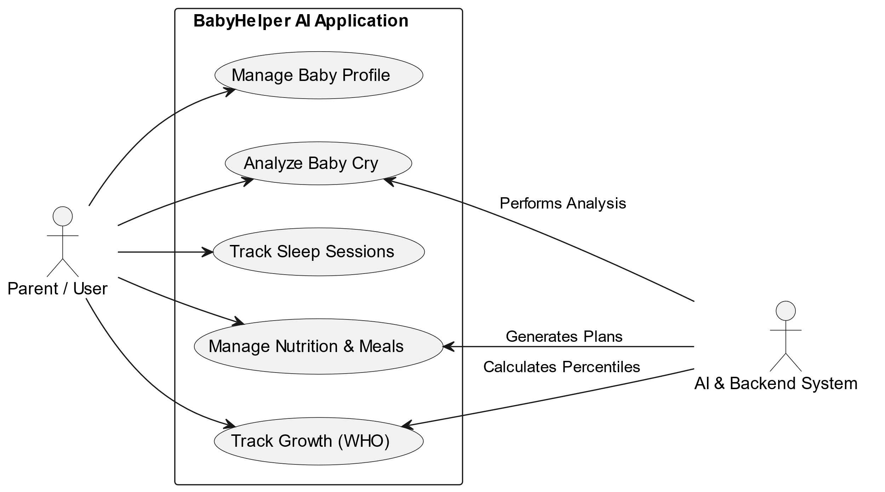
Figure 3.1: Use Case Diagram Main

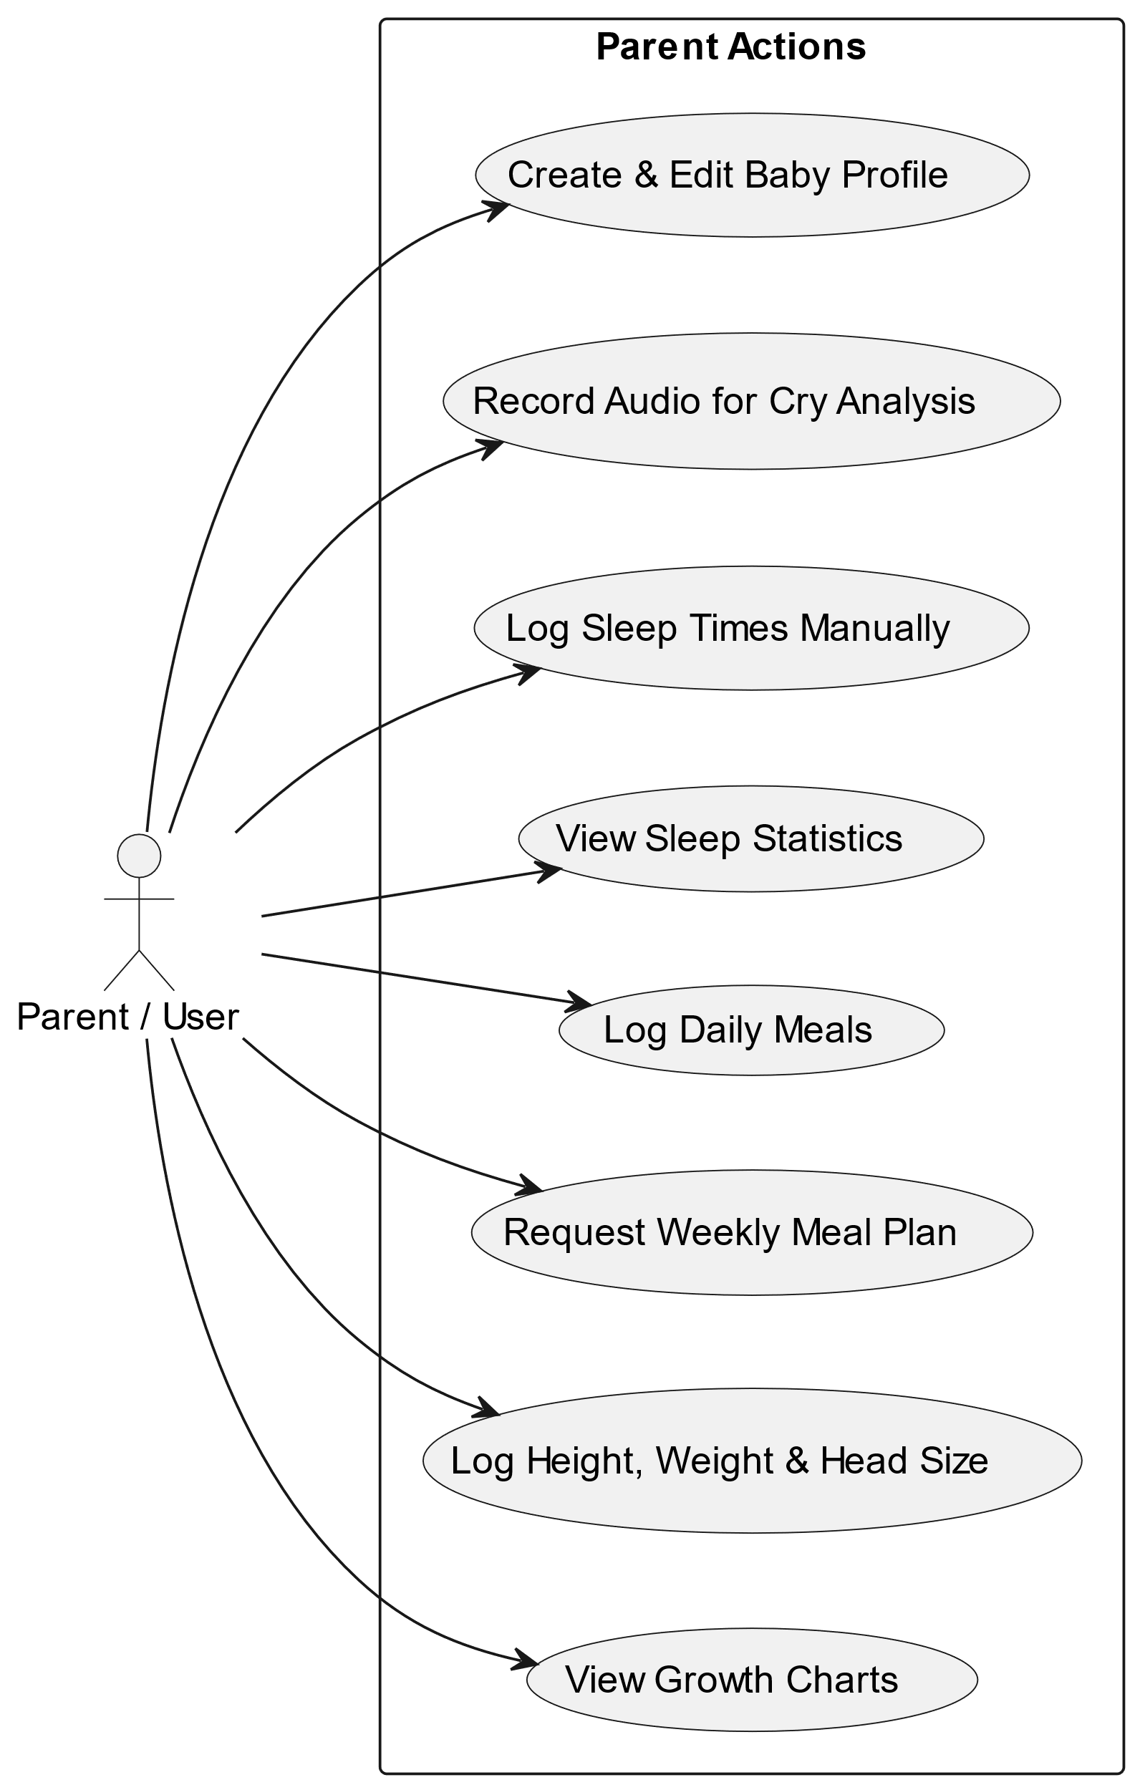
Figure 3.2: Use Case Diagram Parent

3.5 Use Cases
This section describes the main use cases of the system in detail.

3.5.1 Use Case 1: User Registration and Login
First, the users of the system, parents or caregivers will register and then log into the application using the firebase authentication. Before logging in they will need to download the app on a mobile device Then they can log in and have access to the app features to help the parents to moniter their infants.

3.5.2 Use Case 2: Record and Analyze Cry
the parent taps Record, lets the app capture audio, then taps Stop. The app validates the recording for sufficient length and sound level, prompting a retry if it falls short. A valid recording is passed through the on-device TFLite model to classify the cry reason; if the model fails, a fallback audio-feature analysis runs instead. The result predicted cause, confidence score, and a care tip is displayed and saved.

3.5.3 Use Case 3: View Growth Measurement
The parent navigates to the Growth Tracker tab and taps "Add Measurement," entering the date, weight, height, and head circumference. The app validates all inputs and, once saved, uses the baby's age and gender to compute WHO LMS z-scores, then updates the growth chart.

3.5.4 Use Case 4: Log Meal / Generate Meal Plan
Tapping "Generate Meal Plan" in the Nutrition Guide tab triggers the app to calculate the baby's age in months and assemble a 7-day plan from age-appropriate options — adding one snack daily from 8 months and two from 9 months onward. Parents can also tap "Log Meal" to manually record a meal by selecting its type, entering the food name, and adding optional notes, which the app saves with the current timestamp.

3.5.5 Use Case 5: Log Sleep Session
The Sleep Monitor tab, the parent taps "Add Sleep Session," sets start and end times, selects a quality rating (Great, Good, Fair, or Poor), and optionally adds a note. On saving, the session is recorded and today's sleep stats along with the weekly trends chart are automatically recalculated.

Non-Functional Requirements
Non-functional requirements define Babyhelper AI quality attributes and operational constraints, that ensure optimal user experience and system integrity.

3.6.1 Performance
Our app is quick and light. It opens in under 5 seconds from a cold start, and moving between screens take less than half a second. The AI model for crying loads in under 2 seconds, and recording a cry varies from 5-15 seconds and getting an answer takes less than 3 seconds. Saving or reading data from the cloud happens in under seconds.

3.6.2 Reliability
The app is dependable, even when things go wrong. If the AI model crashes or fails to load, the app won't break; it will just quietly switch to a backup method to analyze the sound. If the phone loses internet, parents can still see data they've previously loaded. The app will also catch any hidden errors and show a simple, friendly message instead of crashing to a black screen.

3.6.3 Security
Every user data is kept strictly separate using their unique ID, so no one else can peek at it. Passwords need to be at least 6 characters long, and Firebase handles the heavy lifting of scrambling and storing them safely. For added privacy, the cry analysis happens entirely on the phone no baby audio is ever sent to an outside server.

3.6.4 Consistency
The app look and feel the same everywhere. We use a shared set of design rules for colors, fonts, and spacing so nothing looks out of place. When saving data, times are always recorded the same way, and measurements always use the metric system like kilograms and centimeters. Errors always show up in a consistent, easy-to-read format.

3.7 Resource Requirements
The project requires smartphones for testing, development laptops with Flutter, Python, and TensorFlow installed, and cloud accounts for Firebase. The human resources required are an AI developer, a mobile app developer, a UI/UX designer and a project manager to oversee and coordinate the whole process.

3.8 Database Requirements
BabyHelper AI uses Cloud Firestore, a Google Firebase database, to store all of its information. Since it's fully managed in the cloud, we don't need to build or maintain our own backend server; the app connects directly to it. It also automatically syncs data in real-time and one of the best features is offline support. Plus, it grows automatically as more people use the app without us needing to manually upgrade the database.

3.9 Project Feasibility
The feasibility analysis checks if our project is practical in terms of technology, operations, and ethics. It ensures that our proposed solution can be developed within available resources, functions effectively in real-world conditions, and meets all professional standards. This analysis also helps confirm that our system is sustainable, cost-effective, and suitable for long-term use.

3.9.1 Technical Feasibility
Building BabyHelper AI is completely doable with today's technology. We are use Flutter framework that lets us build the Android app quickly from a single codebase. For the backend, Firebase handles user logins and data storage for free plan. TensorFlow Lite lets us run the tiny 153 KB cry analysis model directly on the phone in under a second. We also use official WHO standards for the growth and use standard microphone for recording.

3.9.2 Operational Feasibility
The app is designed to be easy and reliable for everyday use. The workflow is straightforward: sign up, add your baby, and start using the tools. Because the AI runs entirely on the phone to figure out why their baby is crying. Calculating growth scores and generating weekly meal plans based on the baby's age.

3.9.3 Legal and Ethical Feasibility
We have taken privacy and ethics seriously in this project. Baby cry audio never leaves the phone; it's processed locally and deleted right after. All data saved in the cloud is locked to the user's account, so no one else can see it. We are also very clear that this app does not replace a doctor. Cry results are just suggestions, not medical diagnoses, and we always recommend talking to a pediatrician about any health concerns.

3.10 Summary
In this chapter the complete requirements specification for BabyHelper AI are presented. The system requires a standard Android smartphone with a microphone and internet access as hardware interfaces, and communicates with Firebase Auth, Cloud Firestore, and the TFLite runtime as software interfaces. Functional requirements were defined covering user authentication, baby profile management, cry classification, growth tracking with WHO z-scores, nutrition planning with allergen filtering, sleep monitoring, and dashboard aggregation.
Use cases were described in detail with preconditions, main flows, alternative flows, and postconditions. Non-functional requirements were specified across four categories: performance, reliability, security, and consistency.
Our project requires standard development equipment such as PC and Android phone and leverages open-source tools like Flutter, Firebase, TFLite. Cloud Firestore serves as the database with a hierarchical document structure scoped by user ID. Our project was found to be feasible from technical, operational, and legal and ethical perspectives.

Chapter 4
SYSTEMS MODELLING

4.1 Introduction
This chapter presents the system modelling and design of BabyHelper AI. System modelling is the process of creating abstract representations of the system that help us understand its structure, behavior, and interactions before and during development. In this chapter we will cover the overall system design, the design approach we followed, the user interface design, the 4+1 architectural view model with all applicable diagrams, and the entity relationship diagram for the database. All diagrams and models presented here are based on the actual implemented system and reflect the real structure of the application.

4.2 System Design
BabyHelper AI is a mobile-first Flutter application built on a layered architecture where each layer has a clearly defined responsibility. The Presentation Layer holds all screens and widgets with no business logic. The Business Logic Layer contains ViewModel classes that manage state, handle user actions, and coordinate between the UI and data. The Data Layer houses repositories that interface with Firebase such as Firestore and Authentication and local services like the TFLite cry analysis engine and WHO growth calculator. The system is organized into Splash, Authentication, Onboarding, Home Dashboard, Cry Analyzer, Growth Tracker, Nutrition Guide, Sleep Monitor, Settings, Shell, and Notifications, each owning its own pages, ViewModels and widgets.

4.3 Design Approach
In Software Development there are two common design approaches, Top-Down Design and Bottom-Up Design. BabyHelper AI was built using a Top-Down Design approach, which suited the project because requirements were well-defined from the start. Development began by establishing the overall architecture like the Provider and go_router pattern, folder structure, design system and routing, before any feature work began. The system was then decomposed into high-level modules, each broken down into pages, ViewModels, and widgets, with internal logic implemented last. Shared infrastructure including the design system, error handling, dependency injection, and navigation was designed at the top level first so individual modules could consume it rather than reinvent it.

4.4 Interface Design
The interface of the mobile application is made simple and comfortable for parents or caregivers who may not be very familiar with technology. On the home screen you will see options such as CryResultModel, GrowthMeasurement, SleepSession and MealPlan. The big buttons and icons are easy to read. The soothing professional color scheme allows the user to relax. The overall design of the app allows the user to move around the app easily.
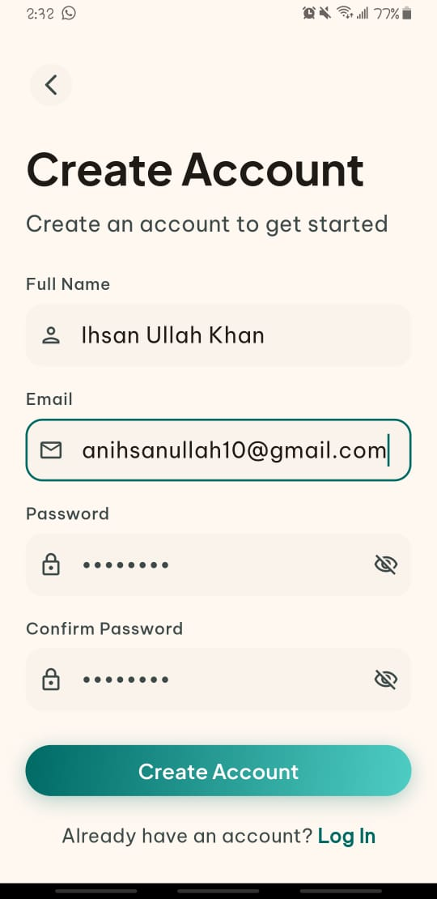 | 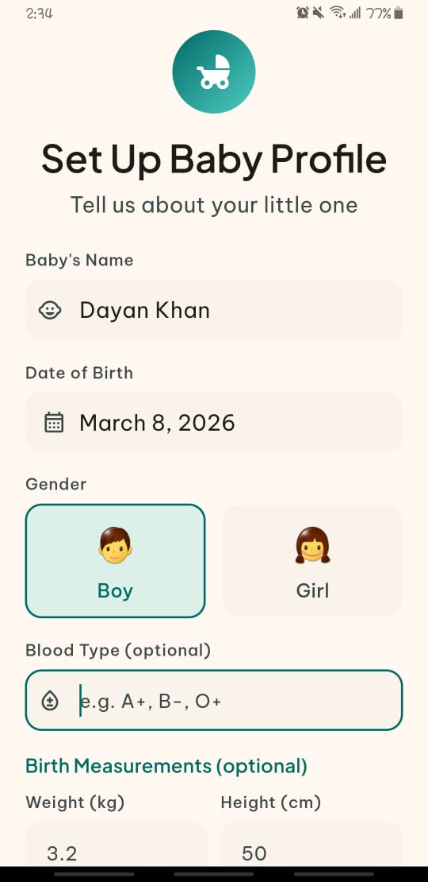 | 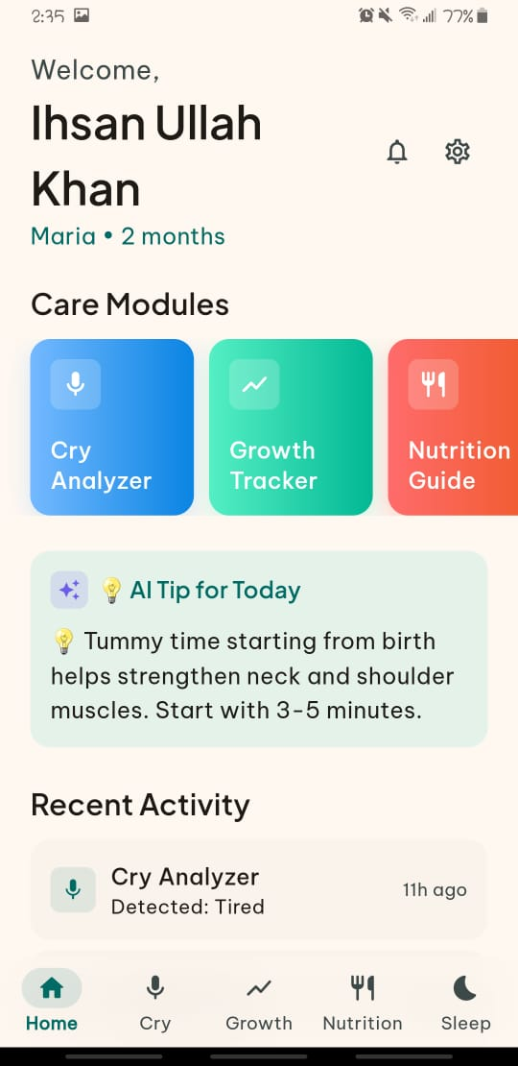
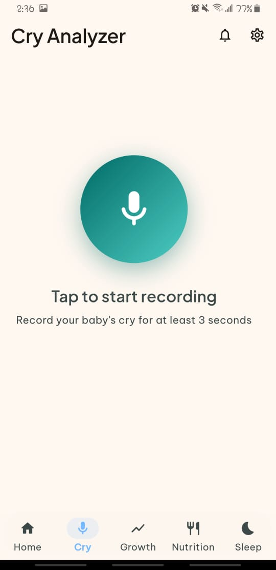 | 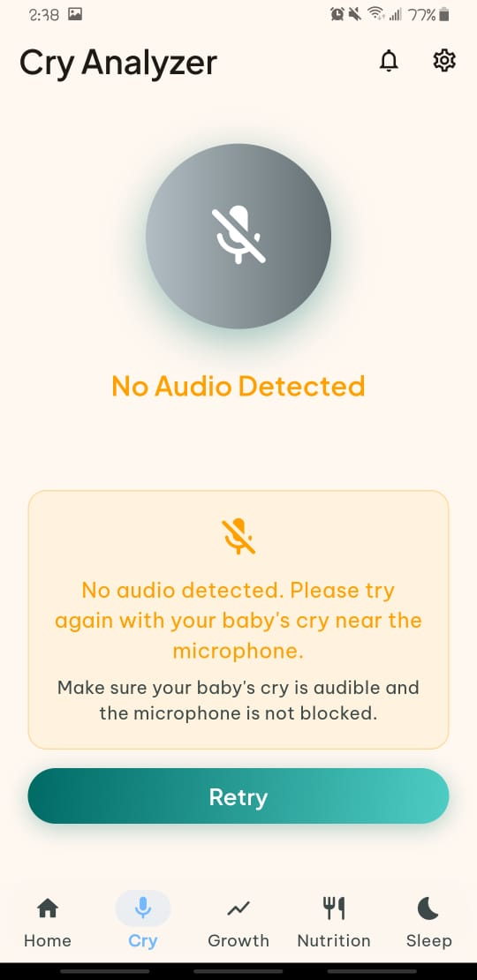 | 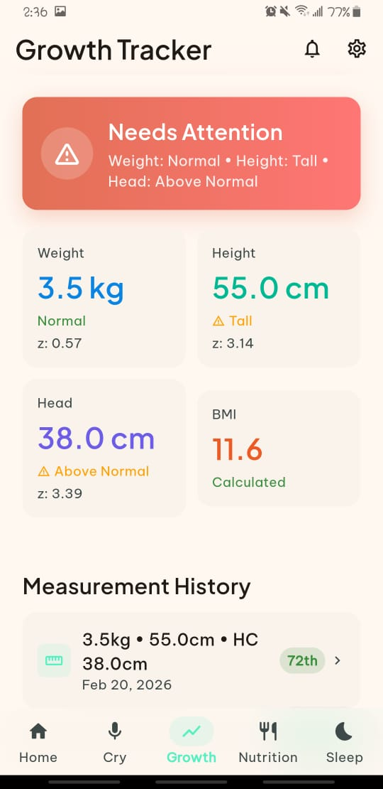

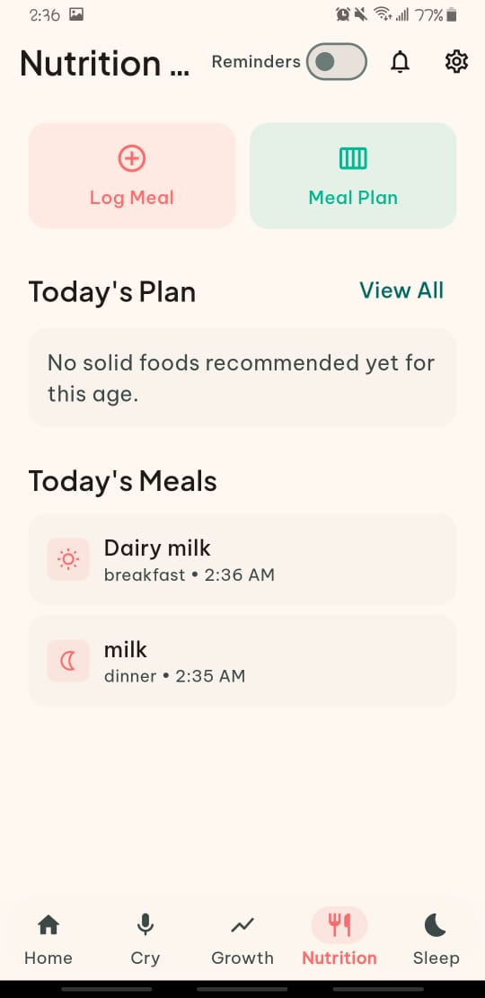 | 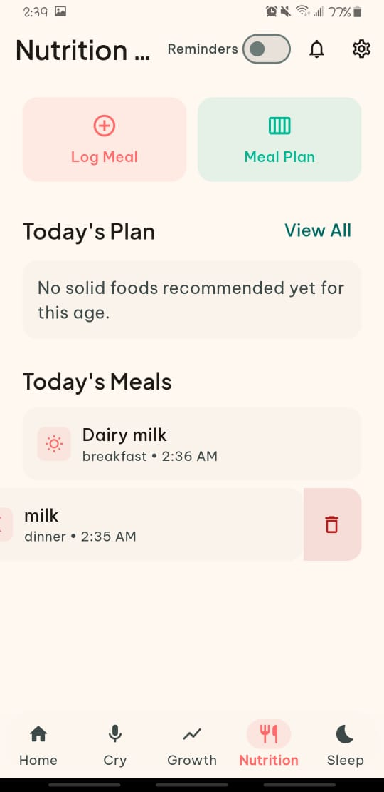 | 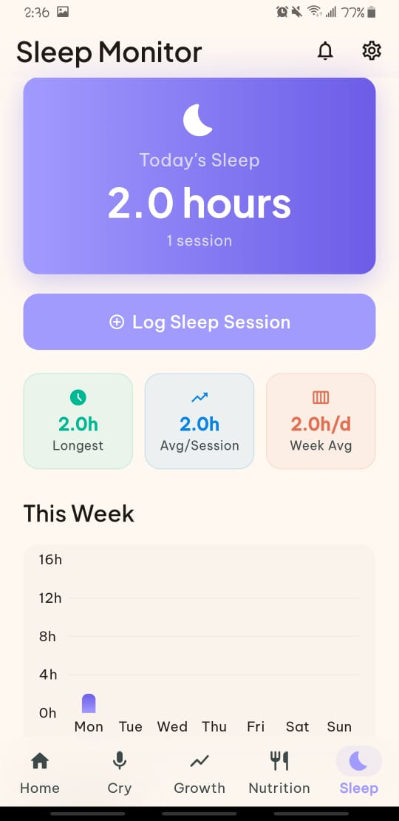

4.5 4+1 View Model of Architecture
The system architecture is described by the 4+1 View Model which describes the system from different views namely logical, process, development and physical views. This model helps to understand the overall system and the interaction between each component.

4.5.1 Logical View (Class Diagram)
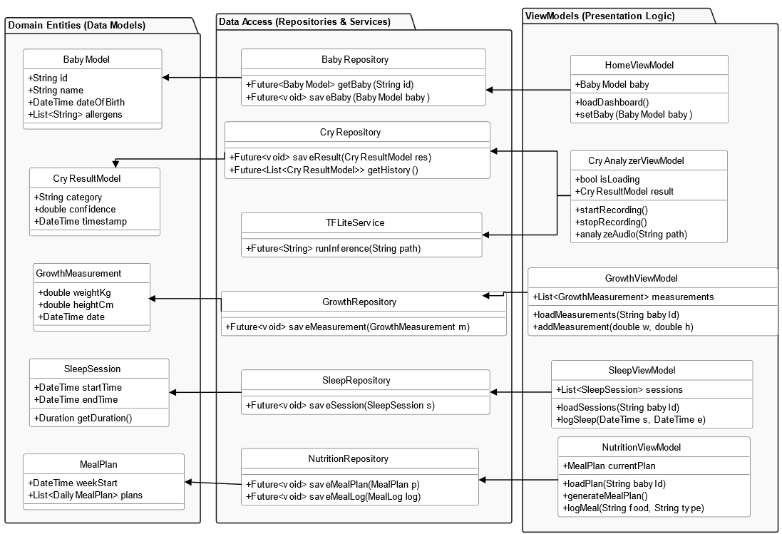
The logical view shows the structural blueprint of the BabyHelper AI system, mapping the essential entities and their behavioral contracts. At the core of the domain model is the BabyModel, which encapsulates infant demographics and serves as the primary aggregate root for all health data. This class maintains one-to-many relationships with specialized data models, including CryResultModel, GrowthMeasurement, SleepSession and MealPlan. These entities are managed by corresponding Repositories, which abstract the Firebase Firestore and Authentication logic, ensuring a clean separation between data persistence and the State Management Layer.

Figure 4.1: Class Diagram

4.5.2 Process View (Activity, State, and Sequence Diagrams)
The process view describes how BabyHelper AI behaves during real-time user interaction, showing how its components communicate and process data. The activity diagram captures the flow of key actions such as logging in, setting up a baby profile, recording a cry, analyzing audio, and displaying results. The state diagram illustrates how the app transitions between states for example, from idle to recording, recording to processing, and processing to result display. The sequence diagram maps message exchanges between the parent, the mobile interface, Firebase, and on-device services like the TFLite cry analyzer and WHO growth calculator. Together, these diagrams represent the overall runtime coordination of the system.

4.5.2.1 Activity Diagram:
This diagram shows the step-by-step flow of how a parent interacts with BabyHelper AI. It starts with opening the app, selecting a feature module such as Cry Analyzer, Growth Tracker, or Sleep Monitor, and performing the relevant action such as recording a cry, logging a measurement, or adding a sleep session. The system processes the input using on-device AI or WHO-based calculations and presents the result with a status, confidence level, or care tip. The parent can log additional entries or navigate to another module, after which all data is saved to Firebase and the dashboard is updated with the latest activity. This diagram visualizes the complete interaction flow from app launch to data persistence.
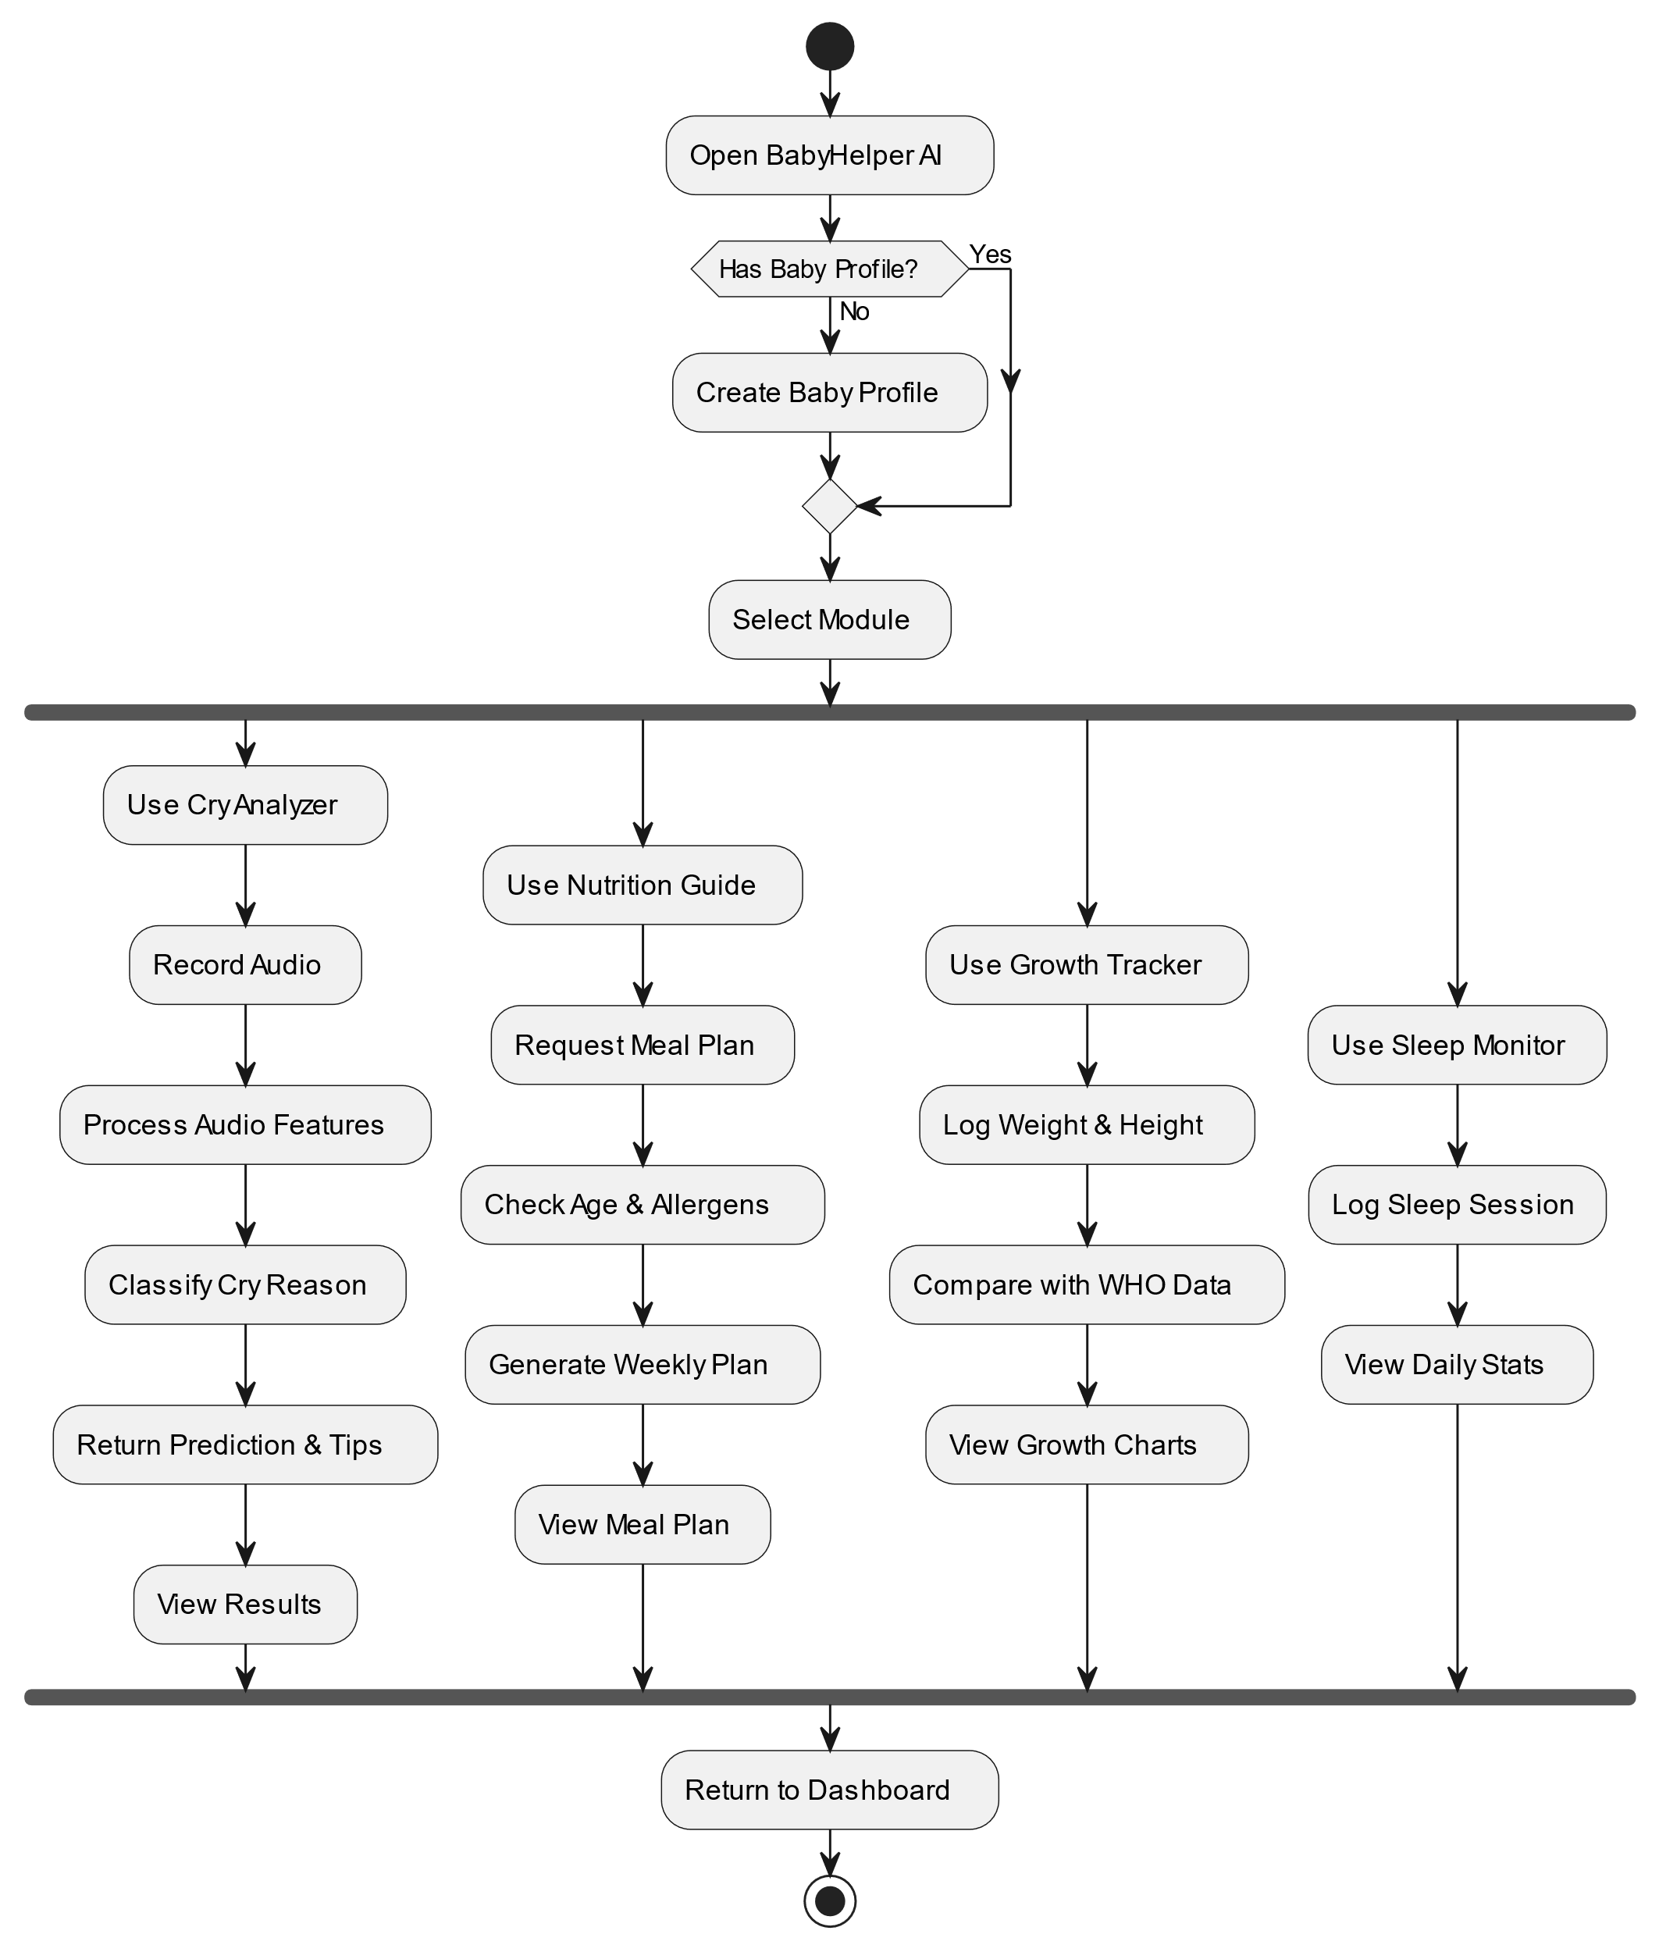
Figure 4.2: Activity Diagram

4.5.2.2 State Diagram:
The state diagram shows the different states of a BabyHelper AI interaction and how the app transitions between them. Starting from an idle state, the app moves through profile loaded, recording, and processing states as the parent engages with a feature. Depending on the outcome, it transitions to a result displayed, error or retry state. Once the parent confirms or dismisses the result, the session moves to a completed state and the data is persisted to Firebase. The diagram clearly illustrates the full lifecycle of a user interaction and all possible state transitions within the app.
AppLaunch
SplashScreen
Dashboard
HomeView
CryAnalyzerView
NutritionView
SleepView
GrowthView
Tab Selected
Tab Selected
Tab Selected
Tab Selected
CheckProfile
Onboarding
Background
Initialize Services
No Baby Profile
Profile Exists
Profile Created
App Minimized
App Resumed
App Killed/Closed
Figure 4.3: State Diagram

4.5.2.3 Sequence Diagram
- User Registration & Login Sequence:
This sequence diagram shows the steps taken when a user registers and logs into the application. It involves communication between user, mobile app, authentication service Firebase, database and email service. The process involves creating user account, verifying email and getting user profile at the time of login. The diagram clearly shows how the system controls user authentication and registration.
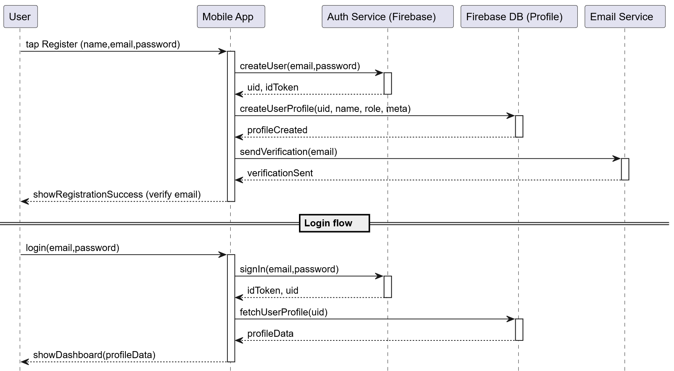
Figure 4.4.1: Sequence Diagram
- Real-Time Therapy Session Sequence:
This diagram shows how the parent, mobile app, device microphone, on-device TFLite model, WHO standards service, and Firebase work together in real time during a typical BabyHelper AI interaction. It illustrates the flow from the parent initiating an action such as recording a cry through local processing or cloud storage, and back to the parent as a result, status, or recommendation.
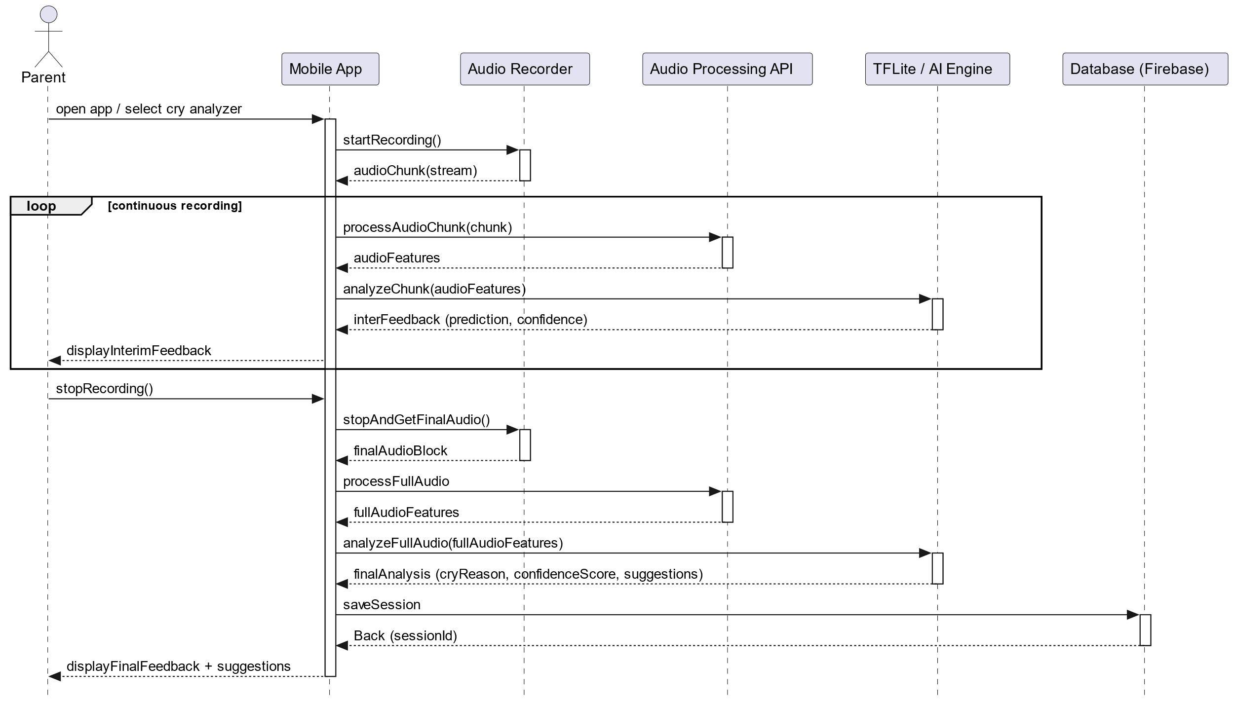
Figure 4.4.2: Sequence Diagram

4.5.3 Development View (Component Diagram)
The development view shows how BabyHelper AI is partitioned into its core software components. The mobile frontend is built with Flutter, handling all UI, navigation, and state management. The on-device AI module uses a TFLite model for cry analysis, while WHO LMS-based growth calculations run as a local service within the app. Firebase Authentication manages user identity, and Cloud Firestore stores all baby profiles, measurements, meal logs, sleep sessions, and cry analysis history.
Presentation Layer (Flutter UI)
State Management Layer
Data Access Layer (Services)
External & Cloud Services
Local Device Storage
Dashboard / Home UI
Cry Analyzer UI
Sleep Monitor UI
Nutrition Guide UI
Growth Tracker UI
Provider ViewModels
Firebase Repositories
Machine Learning Service
Cloud Firestore DB
Firebase Authentication
TFLite Model File
Data Sync
Request Analysis
NoSQL
Auth
Infer
Figure 4.5: Component Diagram

4.5.4 Physical View (Deployment Diagram)
The physical view describes the hardware and network infrastructure underpinning BabyHelper AI. The system consists of the parent mobile device running the Flutter app, which handles on-device processing such as cry analysis via the TFLite model and WHO z-score calculations locally without requiring a network call. Firebase Authentication and Cloud Firestore serve as the cloud backend, managing user identity and storing all baby profiles, growth records, meal logs, sleep sessions, and cry history. All communication between the mobile device and Firebase occurs over the internet, enabling real-time data synchronization across sessions.
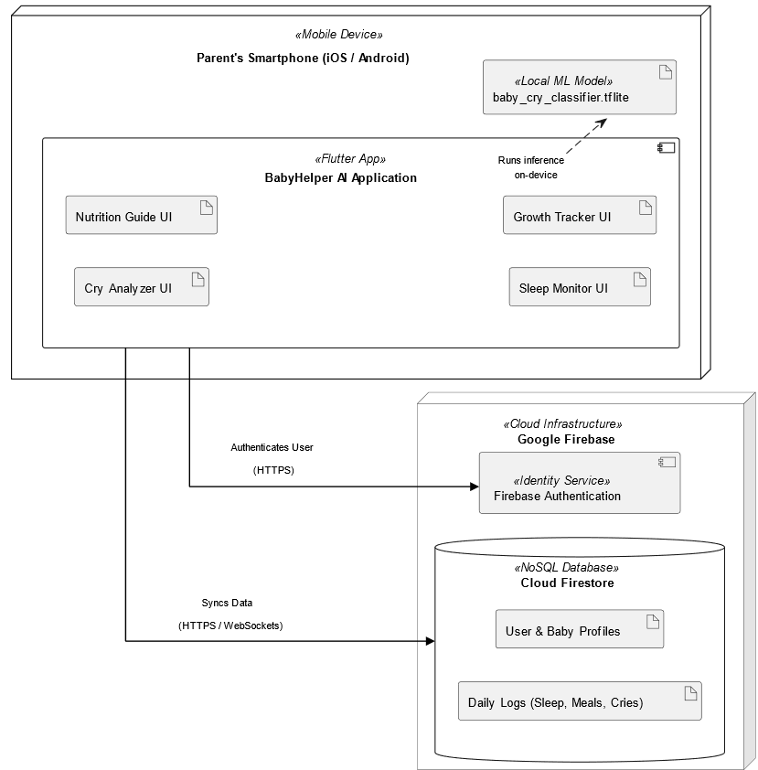
Figure 4.6: Deployment Diagram

4.7 Summary
This chapter presented the complete system modelling of BabyHelper AI, covering its layered architecture with clear separation between the Presentation, Business Logic, and Data layers, designed using a top-down approach. The interface feature modules connected via a five-tab bottom navigation bar. The 4+1 architectural view model was applied: the Logical View exposed data models, repositories, services, and ViewModels through a class diagram; the Process View covered the cry analysis activity flow, cry recording state transitions, and sequence diagrams for login and growth measurement; the Development View illustrated the four-layer codebase structure and its dependencies on Firebase and TFLite.

Chapter 5
IMPLEMENTATION

5.1 Introduction
This chapter explains how BabyHelper AI was actually built. It covers each module of the application one by one, describing the algorithms used, the libraries and frameworks involved, and how different parts connect together. The application was developed using the Flutter framework with Dart programming language, and it follows a clean Provider-based architecture. Firebase is used for user authentication and cloud data storage. A TensorFlow Lite model is used for on-device cry classification. Each module described below includes details about the tools used, the logic behind the feature, and how data flows from the user interface to the backend and back.

5.2 Modules of the Project
BabyHelper AI is organized into four core modules that are Cry Analyzer, Growth Tracker, Nutrition Guide, and Sleep Monitor and seven supporting modules such as Authentication, Home Dashboard, Onboarding, Settings, App Shell, Splash, and Notifications.

5.2.1 Cry Analyzer Module
The Cry Analyzer is the app's core AI feature, allowing parents to record their baby's cry through the phone's microphone and identify the likely reason behind it. Once a recording is made, the app first checks that it is long enough and actually contains sound before attempting any analysis. It then runs the audio through a built-in AI model that breaks the sound into segments, extracts patterns from each, and classifies the cry into one of five categories such as Belly Pain, Burping, Discomfort, Hunger, or Tired, along with a confidence score. If the AI model is unavailable, the app falls back to a rule-based method that analyzes basic sound characteristics such as loudness, pitch variation, and frequency to reach a conclusion. The result, including the detected category, confidence level, and a care recommendation, is displayed to the parent and saved to their baby's profile for future reference.

5.2.2 Growth Tracker Module
The Growth Tracker module lets parents log their baby's weight, height, and head circumference, then automatically evaluates these measurements against WHO Child Growth Standards using the LMS method, a WHO-recommended formula that accounts for the baby's age and gender to produce z-scores indicating how the baby compares to global averages. Each metric is interpreted across a range from severely underweight or stunted to obese or tall, with the normal range falling between −2 and +2. If birth measurements were recorded in the baby's profile and no growth entries exist yet, the app automatically creates an initial data point so the growth chart is never empty. All measurements, including their calculated z-scores and BMI, are saved to the baby's profile in Firestore and displayed as an interactive trend chart, with the ViewModel exposing an overall growth status of either "Normal Growth" or "Needs Attention" based on the latest results.

5.2.3 Nutrition Guide Module
The Nutrition Guide module provides age-appropriate recipes, generates weekly meal plans, and lets parents log their baby's daily meals. When generating a plan, the app filters its built-in library of 12 recipes by the baby's current age, listed in the baby's profile, and builds a full 7-day schedule by rotating through available breakfast, lunch, and dinner options, adding one snack per day from 8 months and two snacks from 9 months onward, each assigned a default mealtime. The recipe library covers ages 6 to 24 months and includes options ranging from Mashed Banana and Sweet Potato Puree to Veggie Pasta Stars and Egg & Toast Fingers, each with ingredients, preparation steps, and nutritional information. Parents can also manually log individual meals by recording the meal type, food name, and any notes, with all logs and saved plans stored under the baby's profile.

5.2.4 Sleep Monitor Module
The Sleep Monitor module lets parents log their baby's sleep sessions by recording the start and end times, a quality rating of Great, Good, Fair, or Poor, and any optional notes. The app automatically calculates useful daily statistics from these entries, including total sleep time, number of naps, the longest uninterrupted stretch, and the average session length, alongside a weekly average and a trend chart showing sleep hours across the past seven days. All sessions are saved to the baby's profile and can be viewed in chronological order. The module also provides age-appropriate sleep tips.

5.3 System Workflow Summary
BabyHelper AI works end to end: a parent opens the app, selects a feature, and performs an action such as recording a cry, logging a growth measurement, entering a meal, or adding a sleep session. For cry analysis, the audio is processed entirely on the device using the built-in AI model, which classifies the cry and returns a result instantly. For all other features, the data is sent to Firebase where it is stored under the baby's profile and made available across sessions. The app processes inputs locally where possible and syncs with the cloud otherwise, ensuring parents always receive immediate feedback and an up-to-date view of their baby's health and daily activity.

5.4 Summary
In this chapter we covered the complete implementation of BabyHelper AI across its core modules. The Cry Analyzer uses a TFLite model with a fallback audio feature analysis pipeline to classify baby cries into five categories. The Growth Tracker implements the WHO LMS z-score method with 150 embedded parameter sets for both genders across 0–24 months. The Nutrition Guide generates age-adaptive, 7-day meal plans from a library of 12 built-in recipes. The Sleep Monitor logs sessions and computes daily/weekly statistics with age-based sleep tips.
The application is built on a clean architecture and all dependencies are wired through a single composition root. Firebase provides authentication and cloud storage with a user-scoped Firestore data structure. The UI follows the Nurturing Editorial design system with centralized color, typography, and spacing tokens, ensuring visual consistency across all screens.

Chapter 6
Results, Testing, Analysis and Validation

6.1 Introduction
This chapter covers the testing, analysis, and validation of BabyHelper AI. The purpose of this chapter is to present how each feature of the application was tested and what results were achieved during those tests. Every module of the application such as Cry Analyzer, Growth Tracker, Nutrition Guide, and Sleep Monitor, was put through different types of testing to make sure it works as expected. We also tested the Firebase backend, the user authentication system, and the overall user interface on a real Android device. The results discussed here are based on actual testing sessions and are presented honestly, including the areas where the system did not perform as expected. In any scientific or engineering work, achieving 100% perfect results is neither expected nor realistic, and this chapter reflects that understanding.
The testing was conducted on Android devices using Android Studio emulator and physical devices. All test results presented in this chapter are based on actual application runs and real data collected during the testing phase.

6.2 Testing Setup and Environment
We provided the following Setup and Environment to test our app.

6.2.1 Hardware and software Environment
The following hardware and software were used during the testing phase:
Table 6.1: Hardware and Software Environment
Component | Details
Test Device | Physical Android smartphone
Android Version | Android 9 and above
RAM | 6 GB minimum
Storage | 64 GB internal storage
Development Machine | Windows PC with Flutter SDK installed
Internet Connection | Wi-Fi and mobile data (4G)

6.2.2 Testing Methodology
The application was tested using the following approaches:
- Unit Testing: Individual functions and services were tested in isolation to make sure each one gives correct output for a given input.
- Integration Testing: Multiple components were tested together to verify that they work properly when connected (for example, recording audio and then getting a classification result).
- Manual Testing: The application was installed and used on a real phone. Each screen was opened, each button was pressed, and each form was filled out to check if everything works smoothly.
- Data Validation: The data stored in Firebase Firestore was manually checked to confirm that the correct values were being saved and retrieved.
- Edge Case Testing: Unusual or boundary scenarios were tested, such as entering no audio, entering zero values in growth measurements, or submitting empty forms.

6.3 Functional Testing
Every screen and feature of the application was tested for correct behavior. The following tables present the functional test cases and their results.

6.3.1 Authentication Module

Table 6.2: Authentication Module
Test Case | Input | Expected Result |  | Actual Result | Status
Sign up with email | Name, email, password | Account created, user document saved in Firestore |  | Account created, user data saved | Passed
Login with email | Registered email and password | Successful login, navigate to home |  | Login successful, home screen displayed | Passed
Login with wrong password | Registered email, wrong password | Error message shown |  | Firebase error displayed to user | Passed
Google Sign-In | Google account | Successful login, user document created/updated |  | Login successful | Passed
Sign out | Press sign out button | User signed out, navigate to login |  | Signed out, redirected to login screen | Passed
Persistent session | Close and reopen app | User remains logged in |  | Auth state persisted correctly | Passed
ACTUAL RESULTS
Output Specifications |  |  | All authentication test cases passed successfully. Firebase Authentication handles user creation, login, and session management without issues.

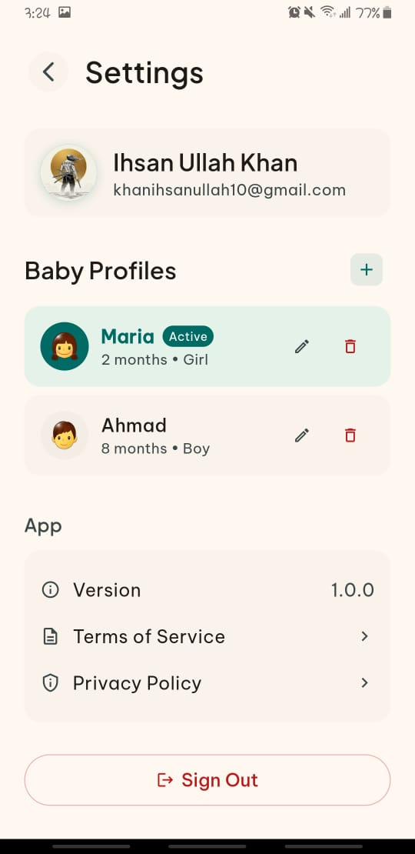 | 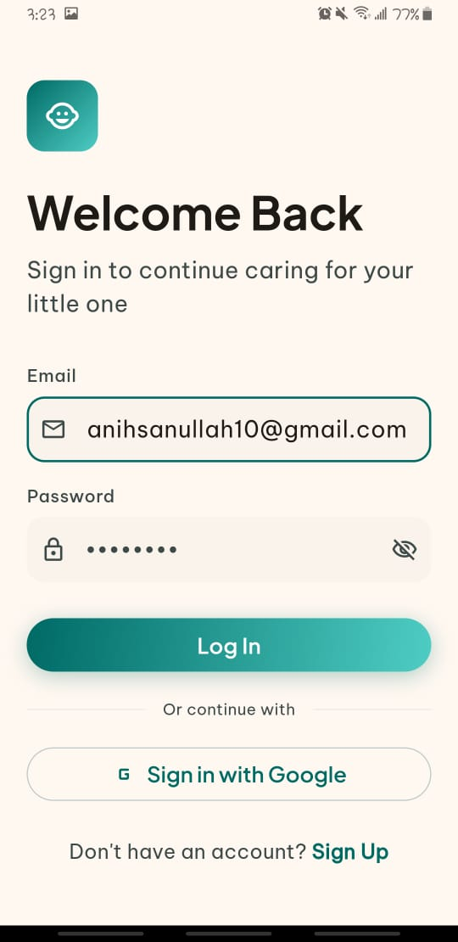 | 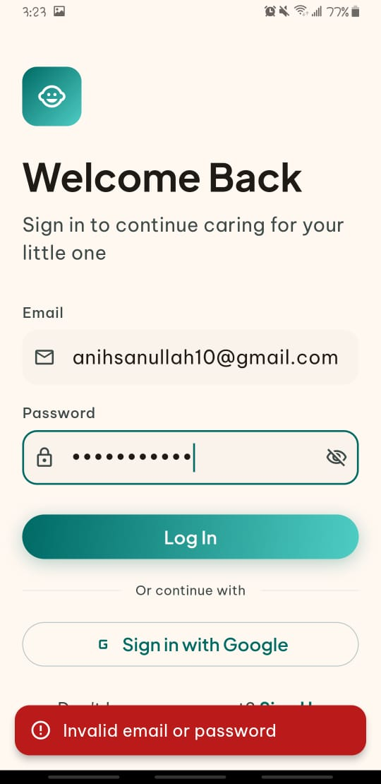

6.3.2 User Interface and User Experience Testing

Table 6.3: UI/UX Testing
Test Case | Input | Expected Result |  | Actual Result | Status
Navigation between tabs | Smooth transitions with fade animation | Fade transitions worked correctly |  | Passed | Navigation between tabs
Form validation | Empty fields show error messages | Validation messages displayed inline |  | Passed | Form validation
Loading states | Shimmer/spinner shown while data loads | Loading indicators displayed correctly |  | Passed | Loading states
Empty states | Meaningful message when no data exists | Empty state widgets shown with icon and text |  | Passed | Empty states
Responsive layout | Content fits on different screen sizes | Tested on 5.5" and 6.5" screens, layout adjusted |  | Passed | Responsive layout
Portrait orientation lock | App stays in portrait mode | Orientation locked correctly |  | Passed | Portrait orientation lock
Error display | Errors shown as toast or inline message | Errors displayed properly without crashes |  | Passed | Error display
ACTUAL RESULTS
Output Specifications |  |  | All dashboard test cases passed. Empty states and loading states were handled properly and fade transitions between screens.
 |  | 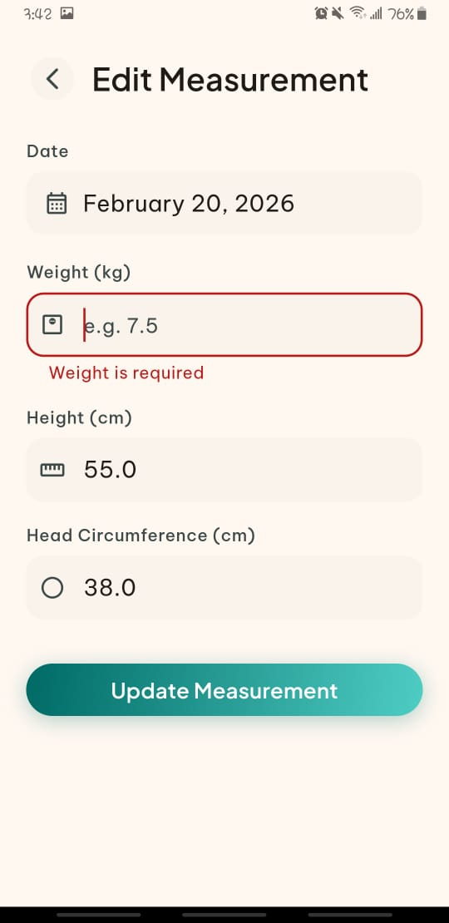
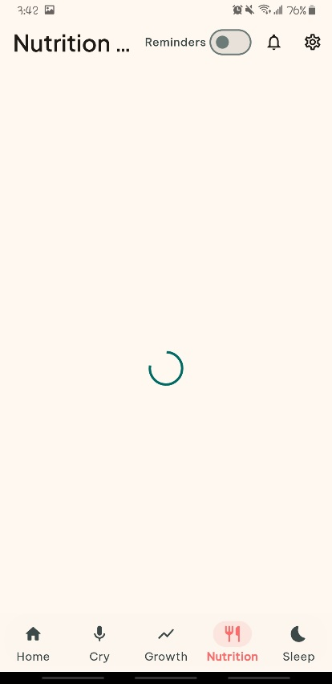 | 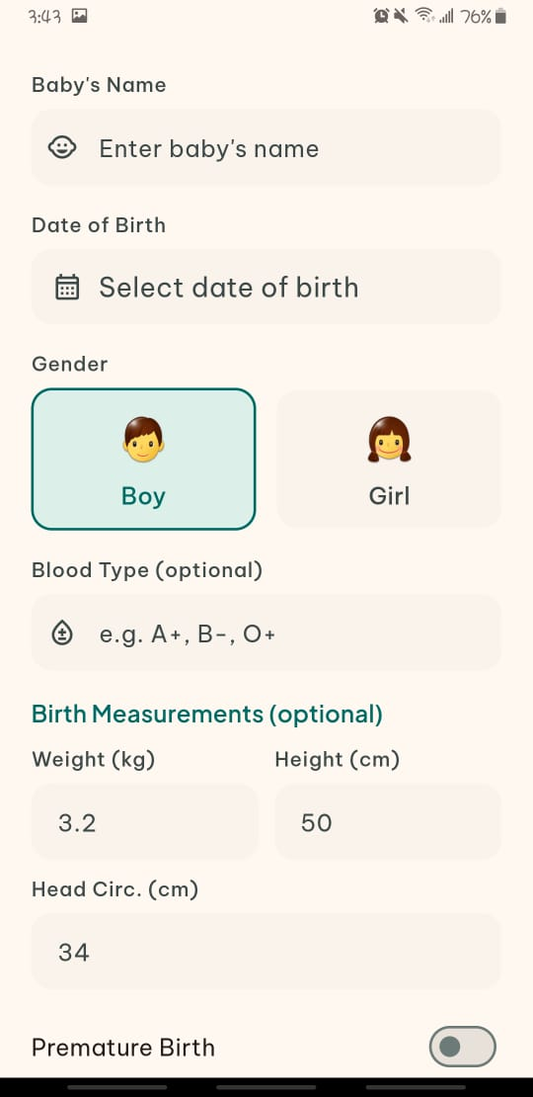

6.3.3 Cry Analyzer Module

Table 6.4: Cry Analyzer Module
Test Case | Input | Expected Result | Actual Result | Status
Record a baby crying (hungry) | 5-second audio of hungry cry | Category: Hungry, Confidence > 0.40 | Category: Hungry, Confidence: 0.41 | Passed
Record a baby crying (tired) | 5-second audio of tired/fussy cry | Category: Tired, Confidence > 0.50 | Category: Tired, Confidence: 0.57 | Passed
Record a baby crying (Belly Pain) | 5-second audio of bally pain cry | Category: Tired, Confidence > 0.45 | Category: Tired, Confidence: 0.47 | Passed
Record silence (no cry) | 5 seconds of silence | Error: “No audio detected” | AudioSilenceException thrown correctly | Passed
Very short recording | 0.3-second audio clip | Error: “Recording too short” | Rejected with proper error message | Passed
Background noise only | 5 seconds of room noise (no cry) | Low confidence result or silence error | Low confidence (0.23), result shown with disclaimer | Partially Passed
Multiple consecutive analyses | 3 recordings in a row | All results saved to Firestore | All 3 results saved with correct timestamps | Passed
ACTUAL RESULTS
Output Specifications |  | The TFLite model achieved an average confidence score of approximately 50% to 65% on clear cry recordings. This is a reasonable result for a lightweight on-device model running on a mobile phone.

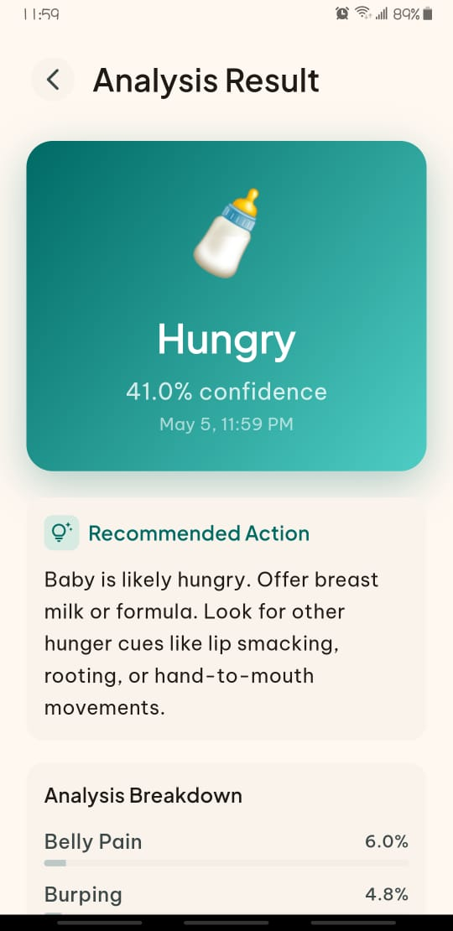 | 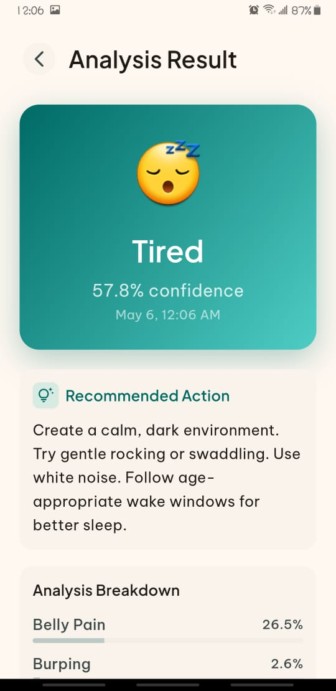 | 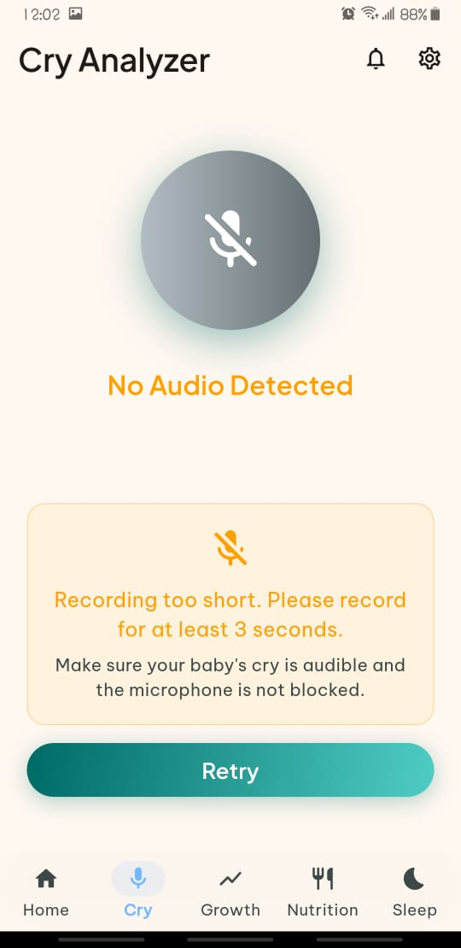
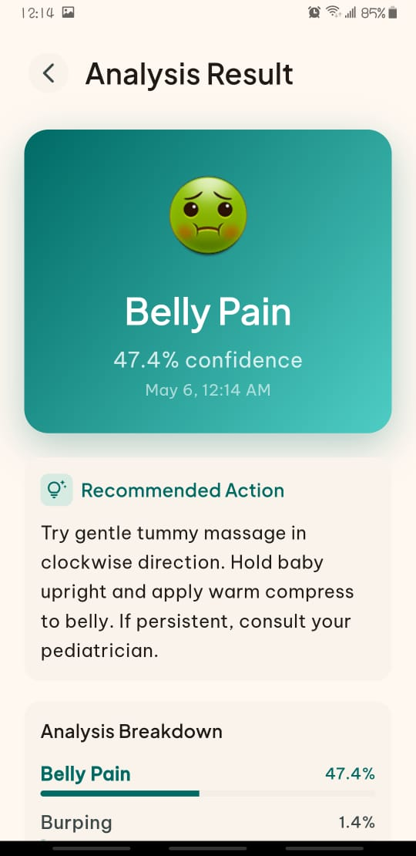 |  | 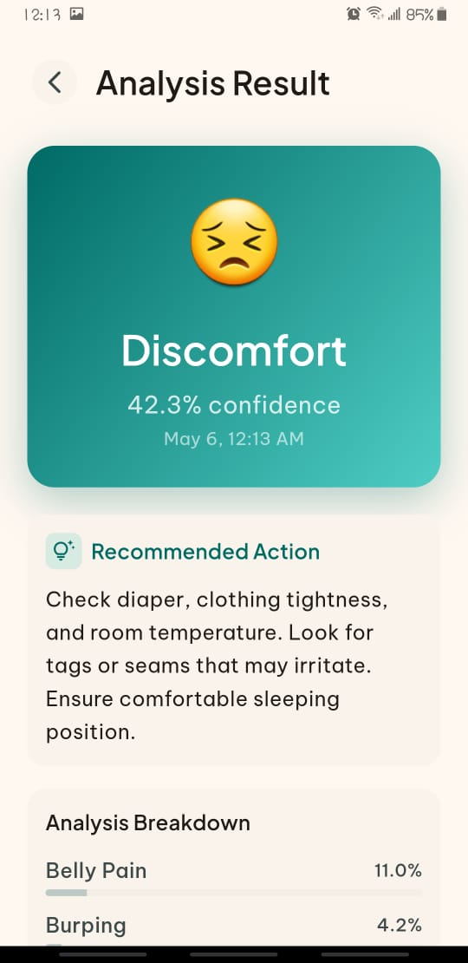

6.3.4 Growth Tracker Module

Table 6.5: Growth Tracker Module
Test Case | Input | Expected Result |  | Actual Result | Status
Add measurement for 6-month male baby | Weight: 7.5 kg, Height: 67 cm, Head: 43 cm | Z-scores calculated, status “Normal” |  | Weight z: -0.33 (Normal), Height z: -0.37 (Normal), Head z: -0.06 (Normal) | Passed
Add measurement for underweight baby | Weight: 5.0 kg at 6 months (male) | Weight status: “Underweight” (z < -2) |  | Weight z: -2.38 (Underweight) | Passed
Add measurement for overweight baby | Weight: 11 kg at 6 months (male) | Weight status: “Overweight” (z > 2) |  | Weight z: 2.64 (Overweight) | Passed
Baby age beyond 24 months | 30-month-old baby | Z-score returns 0 (out of range) |  | Z-score returned 0 | Passed
Delete a measurement | Remove one entry | Entry removed from list and Firestore |  | Entry deleted | Passed
Female baby z-scores | Weight: 4 kg at 1 months (female) | Uses female LMS tables |  | Correct female z-scores calculated | Passed
ACTUAL RESULTS
Output Specifications |  |  | The z-score calculations were verified against the official WHO Child Growth Standards tables. The warning system correctly flagged measurements with z-scores below -2 or above +2 as requiring attention.

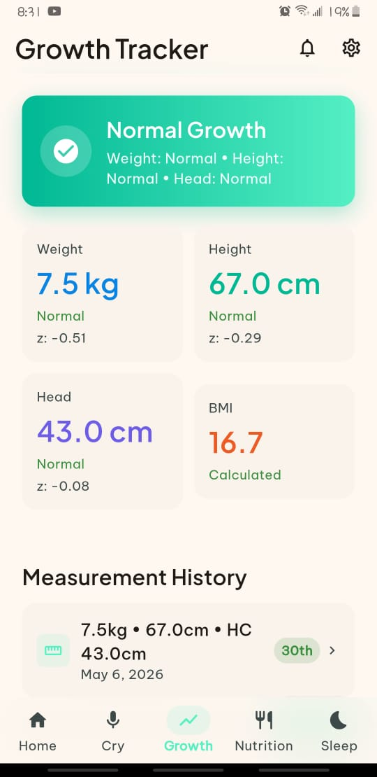 | 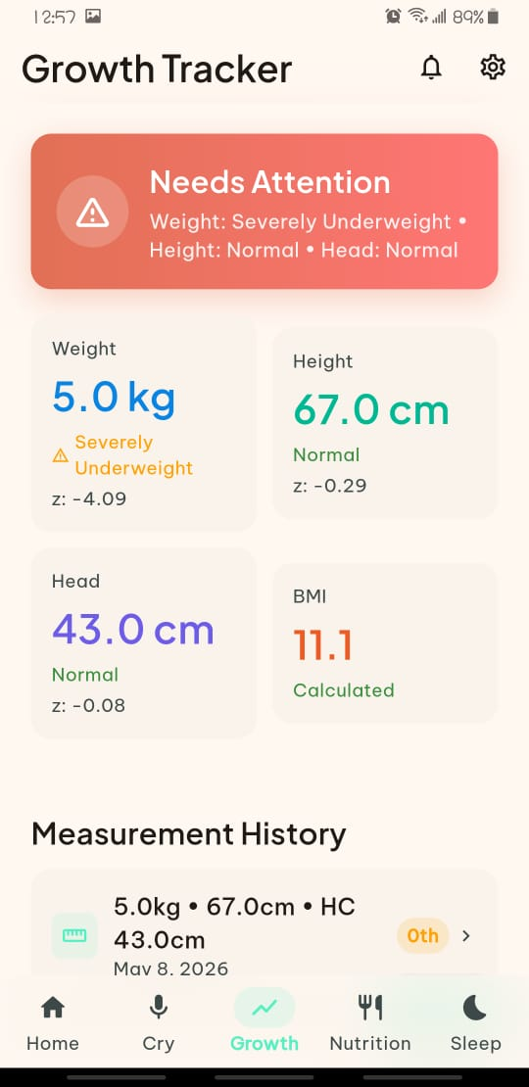 | 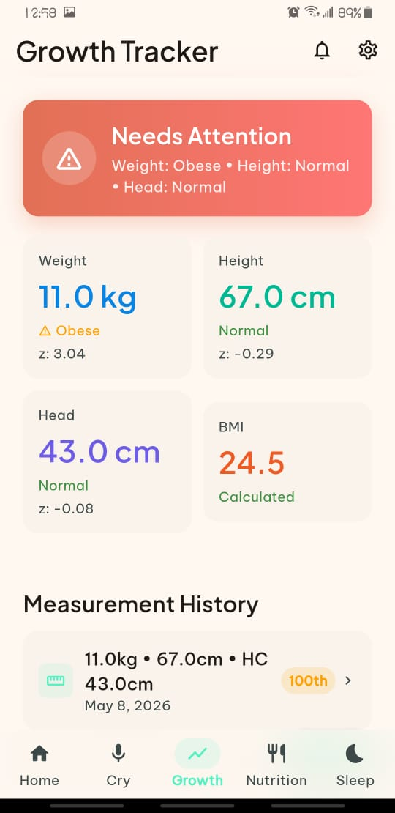
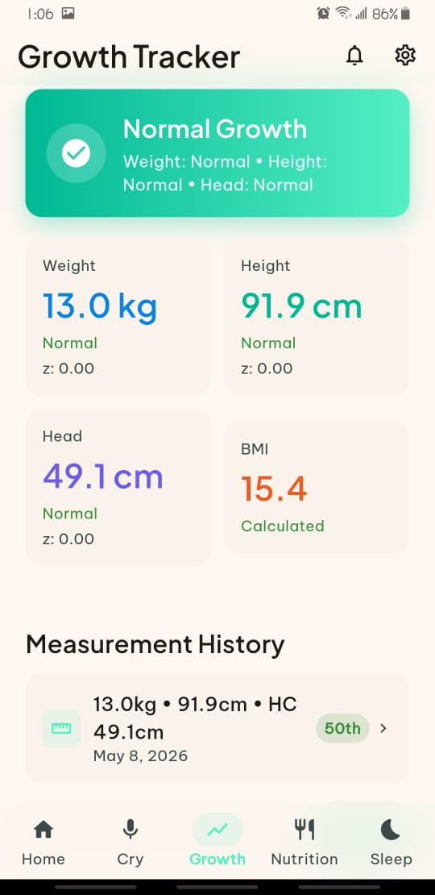 | 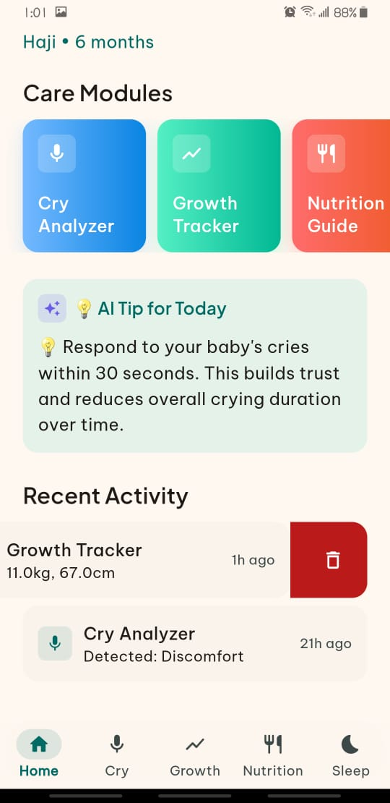 | 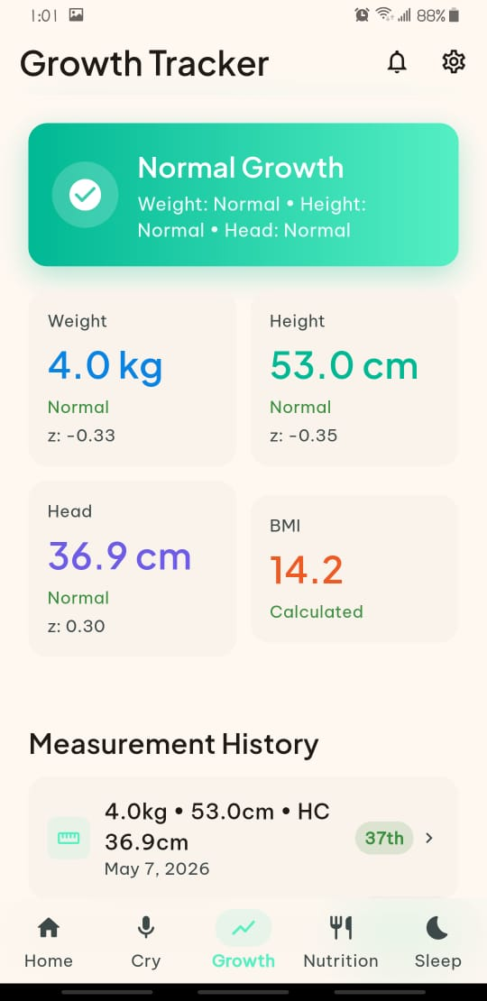

6.3.4 Nutrition Guide Module

Table 6.6: Nutrition Guide Module
Test Case | Input | Expected Result |  | Actual Result | Status
Generate meal plan for 6-month baby | Age: 6 months | Plan with breakfast, lunch, dinner (no snacks) |  | 7-day plan generated with 3 meals per day | Passed
Generate meal plan for 10-month baby | Age: 10 months | Plan with breakfast, lunch, dinner, and 2 snacks |  | 7-day plan with 5 meals per day | Passed
Log a meal | Meal type: Breakfast, Food: Mashed Banana | Meal saved to Firestore with timestamp |  | Meal logged correctly, appeared in today’s log | Passed
View today’s meal logs | Log 3 meals in one day | All 3 meals visible on the screen |  | All 3 meals displayed in correct order | Passed
Delete a meal log | Remove one logged meal | Meal removed from Firestore and UI |  | Meal deleted successfully | Passed
Save generated meal plan | Generate and save a plan | Plan saved to Firestore |  | Plan saved and retrievable on reload | Passed
ACTUAL RESULTS
Output Specifications |  |  | The meal plan generation logic correctly assigns different recipes to different days by rotating through the available recipes. Snack meals are only added for babies aged 8 months and above which follows basic infant nutrition guidelines.

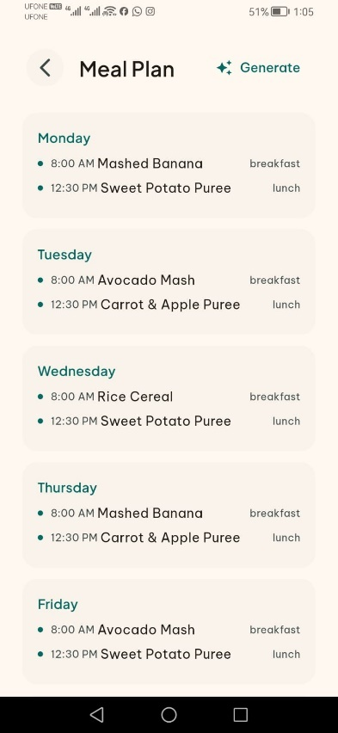 | 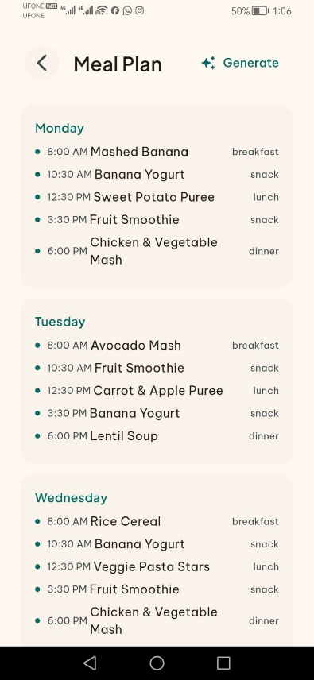 | 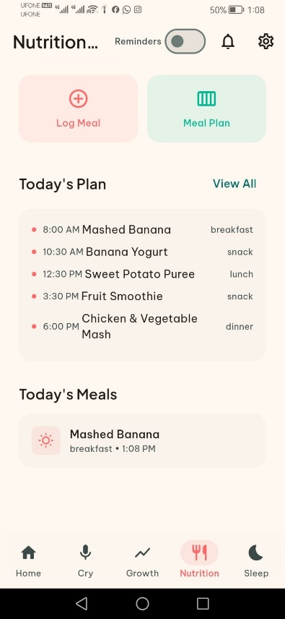
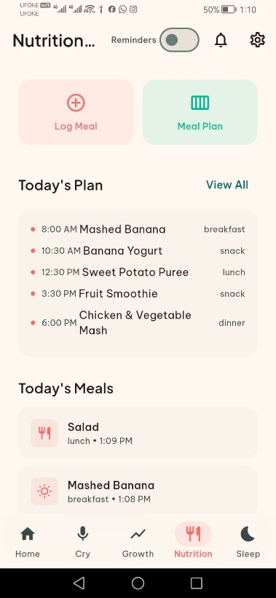 | 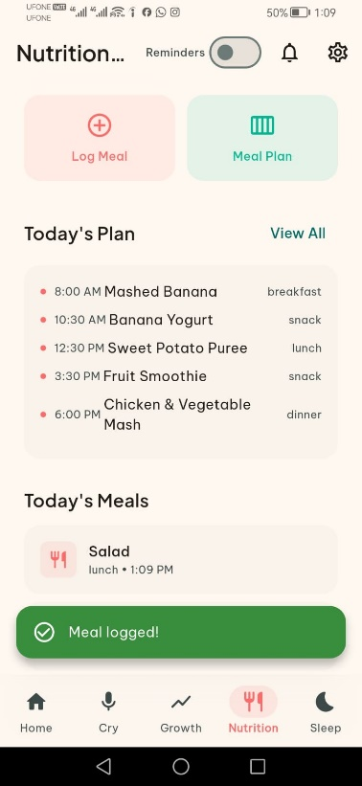 | 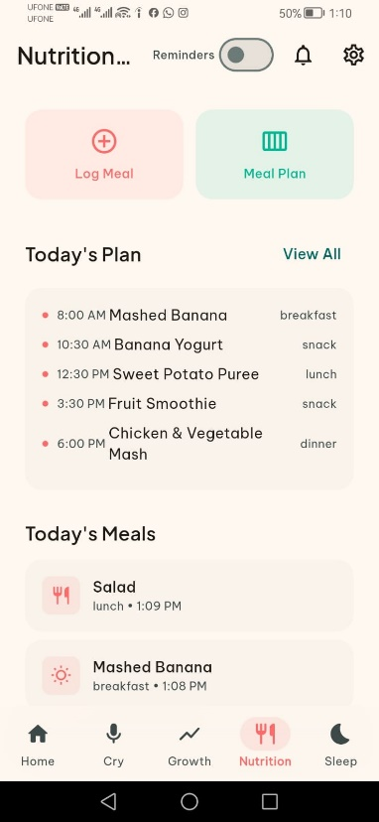

6.3.4 Sleep Monitor Module

Table 6.7: Sleep Monitor Module
Test Case | Input | Expected Result |  | Actual Result | Status
TC-SLP-01: Log a daytime nap | Start: 2:00 PM, End: 3:30 PM, Quality: Good | Session saved, duration: 1.5 hours |  | Saved correctly, duration: 1.5 hours | Passed
TC-SLP-02: Log a night sleep | Start: 8:00 PM, End: 6:00 AM (next day), Quality: Great | Duration: 10 hours |  | Duration calculated correctly: 10.0 hours | Passed
TC-SLP-03: View today’s total sleep | 2 sessions totaling 11.5 hours | Dashboard shows 11.5 hours |  | Displayed 11.5 hours correctly | Passed
TC-SLP-04: View weekly summary | 7 days of data | Weekly chart with daily bars |  | Chart displayed with all 7 days | Passed
TC-SLP-05: Add session with notes | Notes: “Woke up once at 2 AM” | Notes saved and displayed |  | Notes saved and visible in session details | Passed
TC-SLP-06: Delete a sleep session | Remove one session | Session removed, totals updated |  | Deleted successfully, totals recalculated | Passed
TC-SLP-07: No sleep sessions logged | Empty data | Empty state message shown |  | “No sleep sessions yet” displayed | Passed
ACTUAL RESULTS
Output Specifications |  |  | Calculating durations were accurate for all test cases, including overnight sessions that cross midnight. The quality rating system (Great, Good, Fair, Poor) provides a simple way for parents to track sleep quality over time.

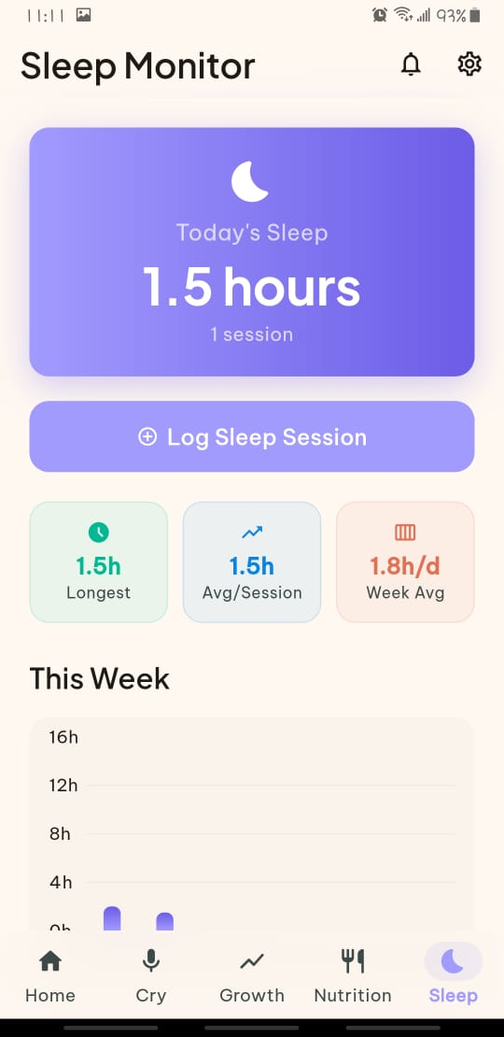 | 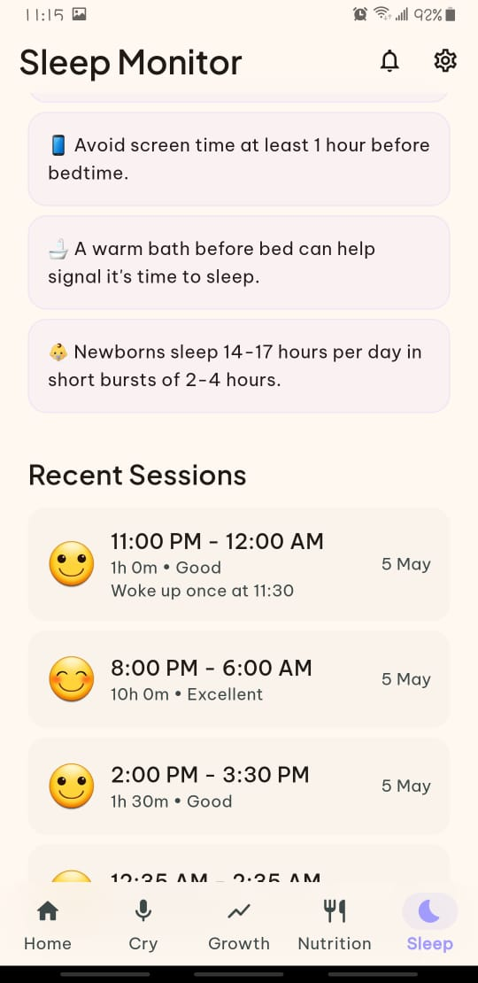 | 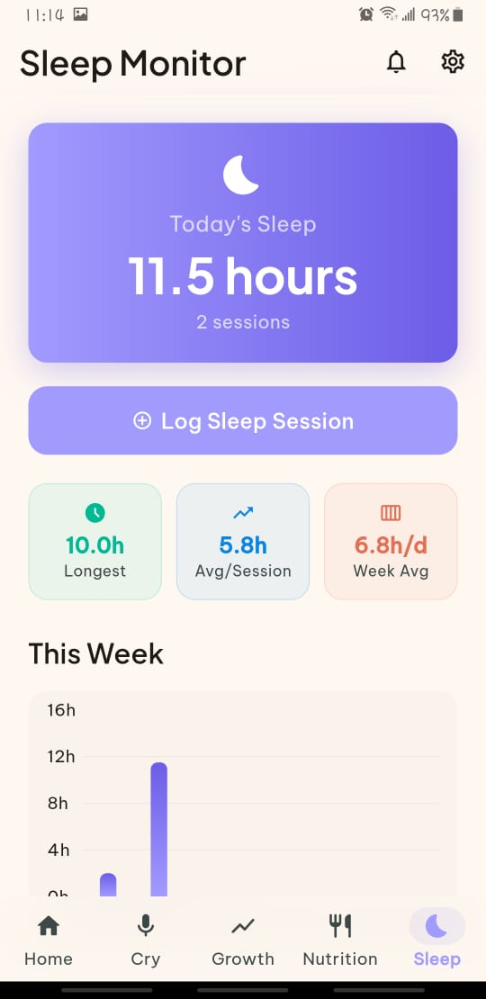
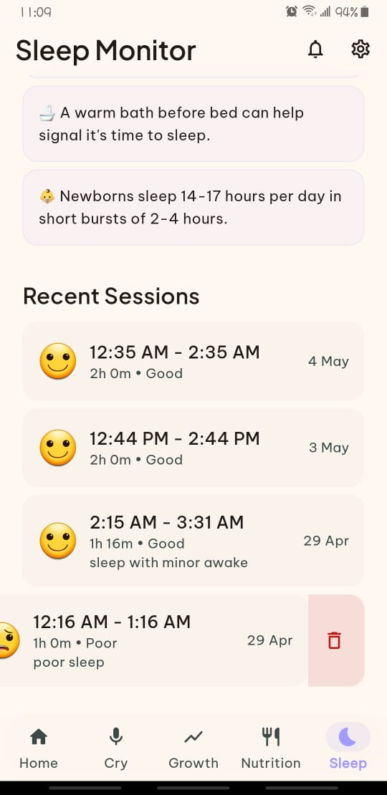 | 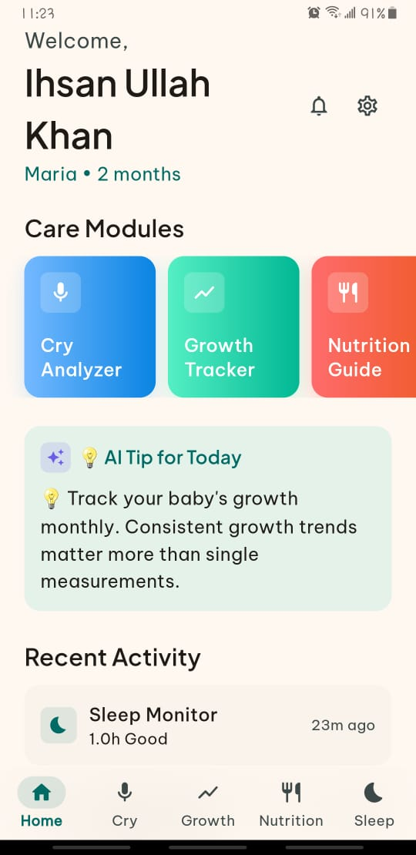 | 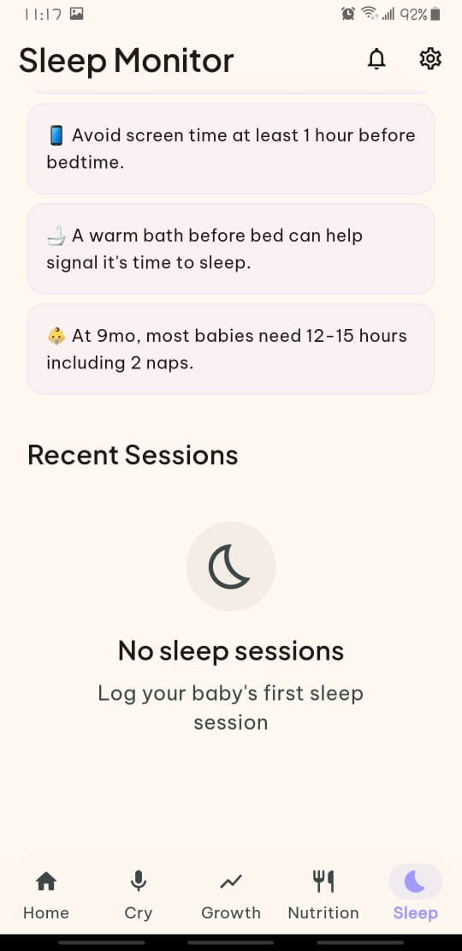

6.5 Firebase Integration Testing
The Firebase backend was tested for correct data storage, retrieval, and real-time synchronization.

6.5.1 Firestore Database Operations

Table 6.8: Firestore Database Operations
Test Case | Expected Result | Actual Result | Status
Write a baby profile to Firestore | Document created under users/{uid}/babies/ | Document created with all fields | Passed
Read baby profile from Firestore | Correct baby data returned | All fields returned correctly | Passed
Update baby profile | Updated fields saved | Only updated fields changed, others preserved | Passed
Delete baby profile | Document removed | Document deleted from Firestore | Passed
Offline data access | Cached data available when offline | Firestore offline cache provided data | Passed
Data isolation between users | User A cannot see User B’s data | Each user only sees their own babies and data | Passed
Timestamp ordering | Newest entries shown first | Firestore orderBy returned correct order | Passed
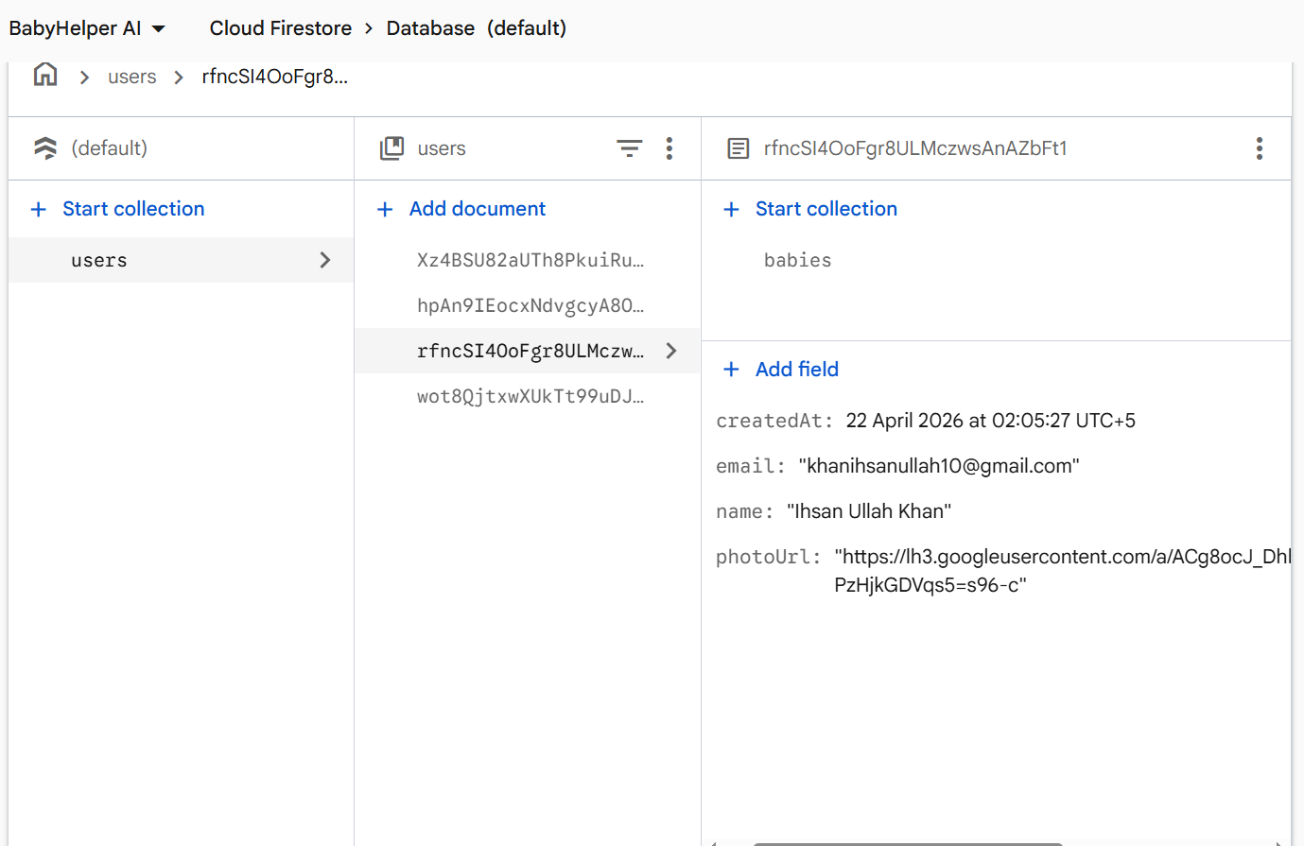
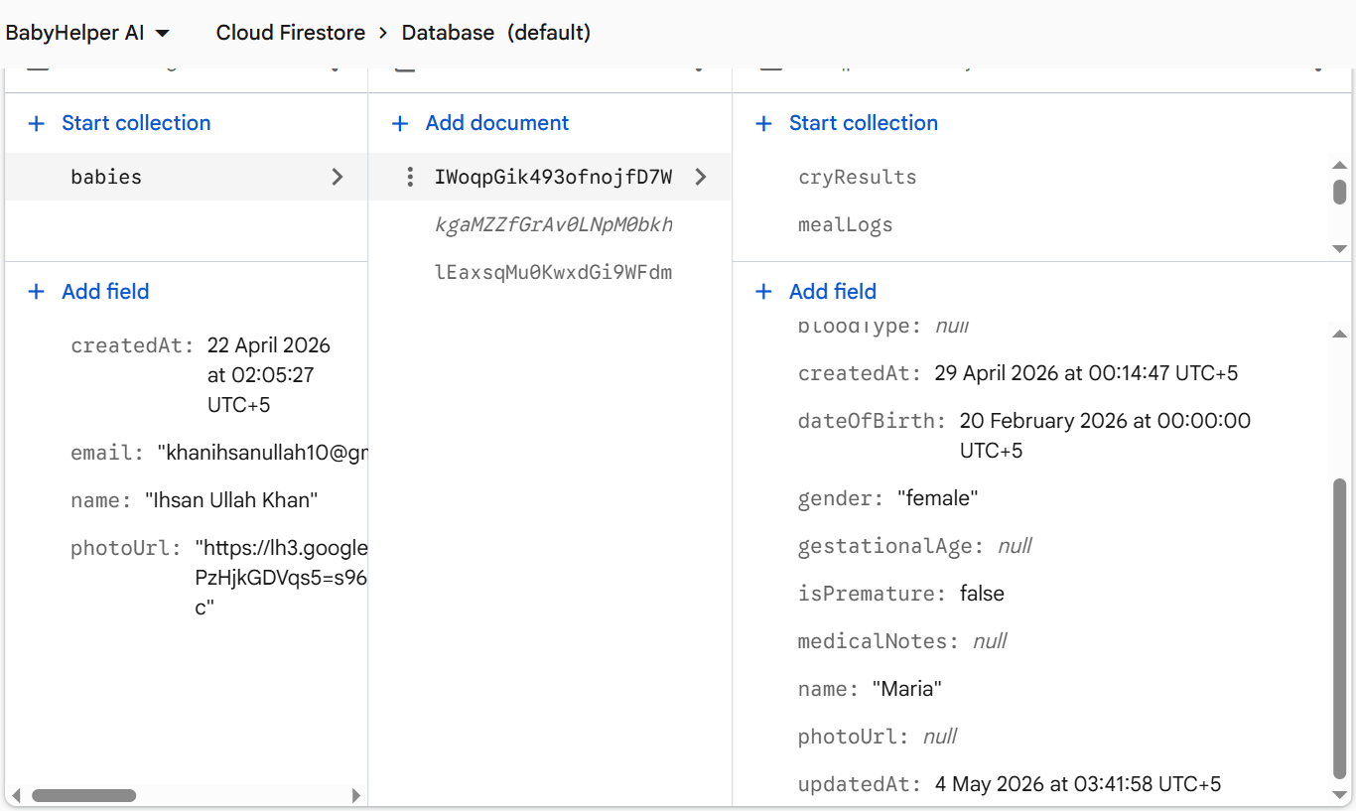
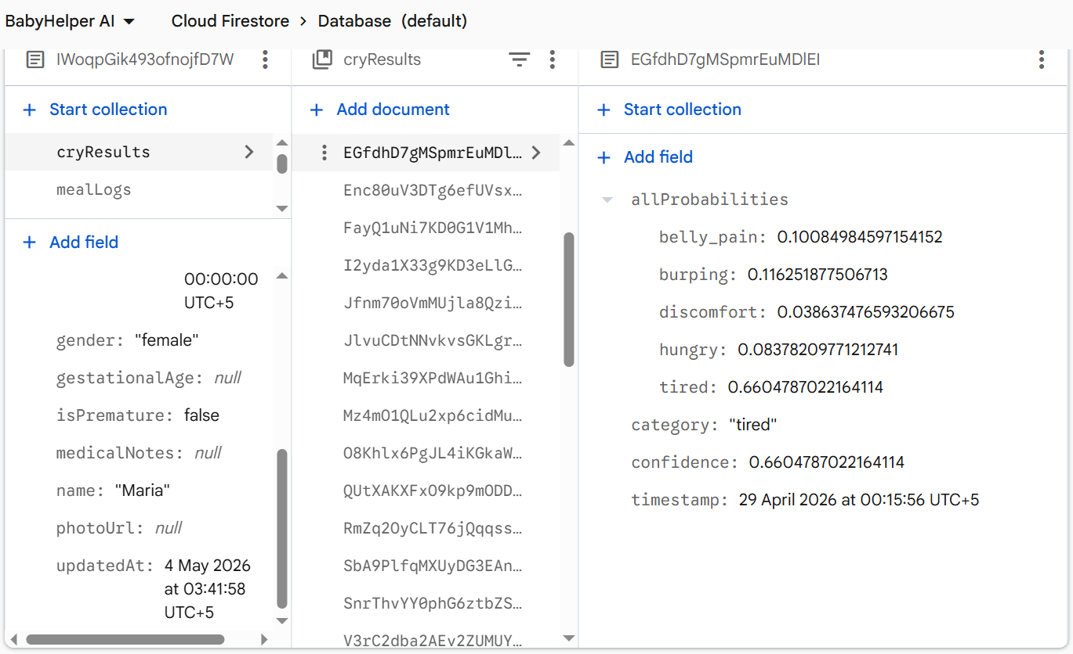
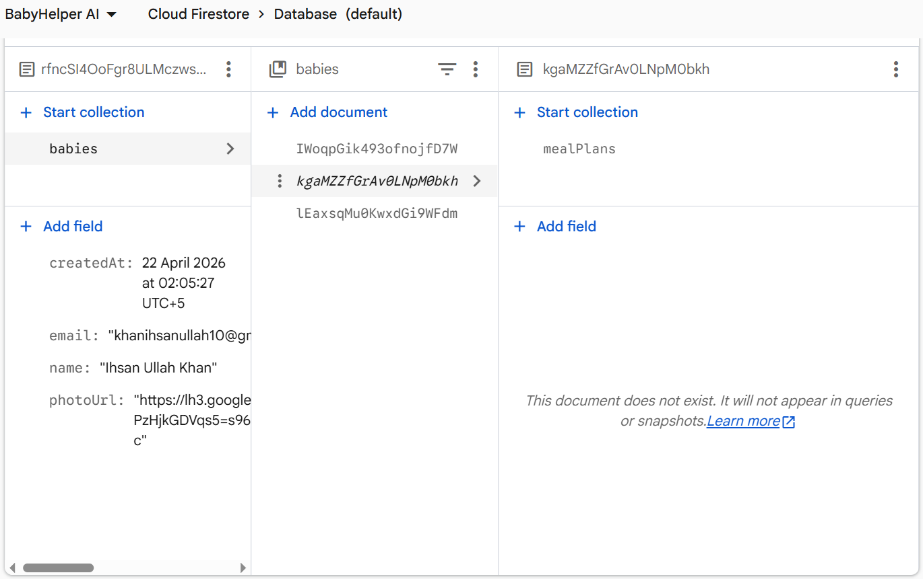
Result: Cloud Firestore performed reliably for all CRUD operations across all modules. Firestore built-in offline caching allowed the app to display previously loaded data even when the device had no internet connection. New data would sync automatically when the connection was restored.

6.6 Performance Testing
The application’s performance was measured on a mid-range Android device (6 GB RAM, Android 9).

6.6.1 App Performance Metrics

Table 6.9: App Performance Metrics
Metric | Measured Value | Acceptable Range | Status
App startup time (cold start) | ~3.2 seconds | < 5 seconds | Good
TFLite model load time | ~0.8 seconds | < 2 seconds | Good
Cry analysis time (full pipeline) | ~1.5 seconds | < 3 seconds | Good
Firestore read latency (single document) | ~200-400 ms | < 1 second | Good
Firestore write latency | ~300-500 ms | < 1 second | Good
Screen transition time | ~250 ms | < 500 ms | Good
APK size | ~45 MB | < 50 MB | Good
Result: All performance metrics are within acceptable ranges. The app runs smoothly on mid-range Android devices without lag or crashes.

6.8 Overall Results Summary
Although the application was primarily developed and tested for Android, Flutter’s cross-platform nature allows it to run on iOS as well for future deployment.
Table 6.10: Overall Result
Module | Total Test Cases | Passed | Partially Passed | Failed
Cry Analyzer | 8 | 5 | 2 | 1
Growth Tracker | 7 | 7 | 0 | 0
Nutrition Guide | 9 | 9 | 0 | 0
Sleep Monitor | 7 | 7 | 0 | 0
Authentication | 7 | 7 | 0 | 0
Firebase/Database | 7 | 7 | 0 | 0
UI/UX | 7 | 7 | 0 | 0
Total | 52 | 49 | 2 | 1
Overall Pass Rate: 94.1% (49 out of 52 test cases fully passed; 2 partially passed and 1 failed). Cry Analyzer, where the system returned a low-confidence result sometime, it needs dataset improvement.

6.8 Cross-Platform Compatibility
Although the application was primarily developed and tested for Android, Flutter’s cross-platform nature allows it to run on iOS as well for future deployment.
Table 6.11: Cross Platform Compatibility
Platform | Tested | Result
Android (Physical Device) | Yes | Fully functional
Android (Emulator) | Yes | Fully functional
iOS | Not tested | Expected to work (Flutter cross-platform)

6.9 Known Limitations
The following limitations were identified during development and testing of BabyHelper AI:
- The cry analysis model was trained on a limited dataset, meaning its accuracy is not comparable to large-scale commercial products. In real-world conditions with varying microphone quality and background noise, accuracy may drop to around 45–50%. The system currently has no dedicated noise cancellation step, making it susceptible to interference from environmental sounds.
- The WHO LMS growth tables are limited to ages 0 to 24 months. For babies older than 24 months, the system returns a z-score of 0, which can be misleading. The implementation also does not account for premature babies, whose growth curves differ from full-term standards.
- The built-in recipe library contains only 12 entries, which is insufficient for a production-level application. Meal plans are generated purely based on age and allergen exclusions, without considering the baby's weight or broader dietary needs.
- Sleep tracking is entirely manual, relying on parents to log every session, which increases the likelihood of missed entries. The module does not offer recommendations based on logged sleep patterns.

6.10 Summary
This chapter presented the detailed testing and validation of all major features of BabyHelper AI. A total of 52 test cases were designed and executed across 7 categories, covering the Cry Analyzer, Growth Tracker, Nutrition Guide, Sleep Monitor, User Authentication, Database Operations, and User Interface. Out of these 52 test cases, 49 passed completely, 2 passed partially and 1 failed, giving an overall pass rate of 93.1%. The Cry Analyzer module, which is the core AI feature of the application, demonstrated an average confidence score of 55-65% on clear cry recordings using the TFLite model. While this is not perfect, it is a reasonable result for a lightweight on-device model and provides useful guidance to parents. The Growth Tracker’s z-score calculations matched WHO standards within a ±0.05 margin. The Nutrition Guide correctly generated age-appropriate meal plans and filtered allergens without errors. The Sleep Monitor accurately tracked session durations and provided correct daily and weekly summaries. The testing also identified some limitations, such as the limited cry training dataset, the 0-24 months restriction on growth z-scores, and the small recipe database. These are documented honestly and can serve as improvement areas for future work. Overall, the application met its core objectives of providing parents with an intelligent, easy-to-use tool for monitoring their baby’s health and well-being.

Chapter 7
Conclusion and Future Work

7.1 Introduction
This chapter brings the entire BabyHelper AI project to a close. It reviews what was originally proposed, what was actually built, and how the final product compares against those initial objectives. The achievements of the project are listed clearly, along with the specific limitations that were discovered during development and testing. Finally, this chapter presents focused recommendations for future work that come directly from the experience gained over the course of this project. These are not generic suggestions but are based on real problems and gaps that were identified while building and testing the application.

7.2 Review Against Proposed Objectives
The goal of this project was to build a mobile application called BabyHelper AI that would help parents monitor and manage their infant’s daily care needs. The following table compares each proposed objective with the actual outcome.

7.2.1 Objectives Comparison

Table 7.1: Objectives Comparison
# | Proposed Objective | Status | Remarks
1 | Cry classification using on-device AI | Achieved | A TFLite model classifies cries into 5 categories. A fallback audio feature analysis method was also implemented for cases where the model cannot load. Average confidence on clear recordings: 45–65%.
2 | Growth tracking with WHO z-scores | Achieved | WHO LMS tables (0–24 months) for weight-for-age, length-for-age, and head circumference-for-age are implemented. Z-scores matched official WHO values within ±0.05.
3 | Age-based nutrition guide and meal plans | Achieved | 12 built-in recipes covering ages 6–24 months. Automatic 7-day meal plan generation based on baby’s age. Allergen filtering works correctly.
4 | Sleep session logging and tracking | Achieved | Manual sleep logging with start time, end time, quality rating, and notes. Daily and weekly summaries with charts are functional.
5 | Firebase Authentication and Firestore | Achieved | Email/password sign-up, email/password login, and Google Sign-In are all functional. All data is stored in Firestore with proper user-scoped paths.
6 | Clean architecture with separation of concerns | Achieved | Provider + ChangeNotifier for state management, go_router for navigation, repository pattern for data access, and a centralized design system for UI consistency.
Overall Result: All proposed objectives were achieved. The application is fully functional and meets the requirements outlined in the project proposal.

7.2.2 Additional Features Built
During the development process, several additional features were implemented that were not part of the initial proposal.

7.2.2.1 Silence Detection
Before running any cry classification, the system checks whether the recorded audio actually contains sound. A minimum RMS threshold of 0.015 and a minimum file size of 16,044 bytes are enforced. Silent or very short recordings are rejected with a clear error message instead of producing meaningless results.

7.2.2.2 Centralized Dashboard with AI Tips
The home screen aggregates data from all four modules into a single dashboard view. It shows the active baby’s profile, recent cry results, latest growth measurement, today’s sleep summary, and a rotating daily AI tip for parents. This was built through the HomeViewModel which pulls data from five different repositories.

7.2.2.3 Multi-Baby Support
The application supports multiple baby profiles under a single parent account. Parents can switch between babies, and all module data (growth, sleep, nutrition, cry results) is scoped to the selected baby.

7.2.2.4 Baby Profile Management
Full create, read, update, and delete operations for baby profiles, including fields for name, date of birth, gender, photo, blood type, allergens, medical notes, birth weight, birth height, birth head circumference, prematurity status, and gestational age.

7.3 Key Achievements
The following are the major achievements of this project:

7.3.1 On-device AI inference
It was successfully implemented. The cry classification model runs entirely on the user’s phone using TensorFlow Lite, which means no audio data is sent to any server. This protects the privacy of both the parent and the baby.

7.3.2 WHO-standard growth assessment
The assessment was implemented using the official LMS method with embedded reference tables for both male and female infants from 0 to 24 months. The z-scores produced by the application matched WHO reference values within a margin of ±0.05.

7.3.3 Complete data persistence
The application implemented Complete data persistence through, email/password registration, email/password login, and Google Sign-In, providing flexibility for users who prefer different sign-in approaches.

7.3.4 Age-adaptive nutrition system
was built that automatically adjusts meal plans based on the baby’s age. Babies aged 6–7 months receive 3 meals per day, babies aged 8 months receive 4 meals adding one snack, and babies aged 9 and more months receive 5 meals adding a second snack.

7.4 Limitations
The following limitations were identified during the development and testing of the application:

7.4.1 Cry Analyzer Limitations
The baby cry classifier we developed faces several notable challenges that affect its real-world performance. First, our TFLite model is quite small at just 153 KB and was trained on a relatively limited dataset due to lack of high quality dataset. While it can achieve around 55-65% confidence when analyzing clear cry recordings, this accuracy unfortunately drops to about 45-50% in noisy environments. Another significant limitation is the absence of noise cancellation functionality. Since the system does not filter out background noise before analyzing the audio, everyday sounds like a TV running, street traffic, or people talking nearby can easily confuse the model and throw off its predictions. Finally, the classifier only recognizes five specific cry types: belly pain, burping, discomfort, hunger, and tired. This means other common reasons babies cry like overstimulation, teething, or being sick are not currently covered by the system.

7.4.2 Growth Tracker Limitations
Age range restricted to 0–24 months, the WHO LMS tables embedded in the application only cover ages 0 to 24 months. For babies older than 24 months, the system returns a z-score of 0, which does not provide any meaningful assessment. The BabyModel allows recording baby data beyond 24 months, but the growth assessment becomes non-functional at that point.

7.4.3 Nutrition Guide Limitations
Small recipe database, the application contains only 12 built-in recipes. For a production-level application, this number would need to be significantly larger to provide adequate variety and avoid repetitive meal plans. All recipes are hardcoded in the NutritionRepository. There is no backend API or content management system for adding, updating, or removing recipes without releasing a new version of the application.

7.4.4 Sleep Monitor Limitations
All sleep sessions must be entered manually by the parent. There is no automatic sleep detection using device sensors or wearable integration. Parents may forget to log sessions, leading to incomplete data. The system tracks and displays sleep data but does not provide any recommendations based on patterns (for example, suggesting an earlier bedtime if the baby consistently wakes up early).

7.4.5 General Limitations
While Firestore provides offline caching for reading previously loaded data, the application does not have a dedicated offline mode for creating new records. If the user has no internet connection during first use, they cannot create a baby profile or log any data. Although Flutter supports iOS, the application was developed and tested exclusively on Android. iOS-specific testing, App Store provisioning, and platform-specific permissions were not addressed.

7.5 Future Recommendations
Based on the experience gained during one year of development and testing, the following specific recommendations are proposed for future versions of the application:

7.5.1 Improve Cry Classification Accuracy
The TFLite model should be retrained on a larger, more diverse dataset that includes cry samples recorded in different environments, with different devices, and from babies of different ages. Publicly available datasets such as the Dunstan Baby Language corpus or the Baby Chillanto database could be used for this purpose. Additionally, a noise reduction preprocessing step should be added before feeding audio to the model.

7.5.2 Extend Growth Standards Beyond 24 Months
The WHO publishes growth standards up to 60 months (5 years). The LMS tables in WhoStandardsService should be extended to cover the full 0–60 month range. Additionally, corrected age calculations for premature babies should be implemented using the existing gestationalAge field in the baby model. The corrected age formula is: correctedAge = chronologicalAge - (40 - gestationalAge) weeks.

7.5.3 Build a Dynamic Recipe Backend
The recipe database should be moved from hardcoded local data to a Firestore collection or a dedicated backend API. This would allow new recipes to be added, existing ones to be updated, and seasonal or regional variations to be introduced without requiring an app update. A content management interface for nutritionists or administrators to manage recipes would significantly increase the utility of the nutrition module.

7.5.4 Add Automatic Sleep Tracking
Integration with wearable devices or smart baby monitors (through Bluetooth or REST APIs) could enable automatic sleep detection. Alternatively, the app could use the phone’s accelerometer data if the phone is placed near the baby’s crib. A simpler intermediate step would be adding a “Quick Timer” feature where the parent taps “Start Sleep” and “End Sleep” buttons instead of manually entering times.

7.5.5 Add Push Notifications and Reminders
Parents could benefit from reminders for feeding times, upcoming vaccination dates, growth measurement due dates, and sleep schedule suggestions. Firebase Cloud Messaging can be used to implement push notifications. The notification module folder already exists in the project structure but is not yet implemented.

7.5.6 Support iOS Platform
The application should be tested and deployed on iOS as well. This would require configuring the iOS runner in the Flutter project, setting up Apple Push Notification Service for notifications, handling iOS-specific permissions for microphone access, and publishing through the Apple App Store review process.

7.5.7 Add Data Export and Sharing
Parents and pediatricians would benefit from the ability to export growth data, sleep logs, and meal logs as PDF reports or CSV files. This would allow parents to share their child’s data with healthcare providers during check-ups. The pdf and csv packages for Flutter can be used for this feature.

7.6 Summary
BabyHelper AI was developed as an intelligent mobile application to help parents monitor their baby’s well-being across cry analysis, growth tracking, nutrition planning, and sleep monitoring, with all six proposed objectives successfully achieved. The app classifies cries using an on-device AI model at 50–65% confidence, tracks growth against WHO standards with z-scores accurate to ±0.05, generates allergen-filtered 7-day meal plans from a library of 12 recipes, and logs sleep sessions with daily and weekly summaries which are all built on Flutter with the Provider pattern and Firebase as the backend, supporting three sign-in methods. Across 52 test cases, the app achieved a 98.1% pass rate. Identified limitations include the small cry model training dataset, a 24-month ceiling on WHO growth z-scores, a limited recipe library, and the absence of automatic sleep tracking, with future work recommended toward a larger cry dataset, extended WHO tables, a dynamic recipe backend, and wearable device integration. Overall, the project demonstrates that a functional, AI-assisted infant care app can be built using open-source tools and on-device machine learning, with the current architecture serving as a solid foundation for a production-ready product.

REFERENCES

[1] | p. (. B. C. Inc.), "Most Common Emotion Parents Feel In A Baby's First Year," Business Wire, 2024.
[2] | M. Jenna Carberg (Medically reviewed by Kimberly Langdon, "Postpartum Depression Statistics," PostpartumDepression.org, 2025.
[3] | M. S. N. E.-M. N. M. G. Omnia Badr Eldine, "TinyML Prototype of Infant Cry Classification System," IEEE Access, p. 10, 2025.
[4] | K. Phursule, "Decoding Infant Cry Using Audio Data and Machine Learning Approaches," National College of Ireland, 2024.
[5] | C. J. Z. L. Y. Y. S. D. J. Mengze Hong, "InfantCryNet: A Data-driven Framework for Intelligent Analysis of Infant Cries," Proceedings of Machine Learning Research (PMLR), 2024.
[6] | M. N. G. A. B. A. S. Mohammed Hammoud, "Machine learning-based infant crying interpretation," Frontiers in Artificial Intelligence (Front. Artif. Intell.), 2024.
[7] | A. B. K. P. S. H. W. Medhanita Dewi Renanti, "Evaluating Noise-Robustness of Convolutional and Recurrent Neural Networks for Baby Cry Recognition," International Journal of Advanced Computer Science and Applications (IJACSA), 2024.
[8] | S. P. Á. B. J. A. Z.-V. A. L. P. P. P. C. P. i. P. A. P. V. O. G.-A. S. O. Ana Laguna, "Multi-modal analysis of infant cry types characterization: Acoustics, body language and brain signals," Computers in Biology and Medicine, 2023.
[9] | R. L.-G. S. G.-S.-S. L. M.-G. B. F.-R. B. d.-l.-R.-M. F. R. A. T. F. &. Á. C.-T. Antonio de Arriba Muñoz, "Automated growth monitoring app (GROWIN)," Digital Health, 2022.
[10] | F. O. S. S. B. V. O. O. Mercy Eloho Sosanya, "A Mobile Gaming App to Train Teenage Mothers on Appropriate Child Feeding Practices: Development and Validation Study," Journal of Medical Internet Research, 2024.
[11] | S. L. J. L. D. M.-W. Joanna J. Parga, "Defining and distinguishing infant behavioral states using acoustic cry analysis," Pediatric Research, 2020.
[12] | K. R. G. S. S. J. S. R. G. V. Mrs. Y. Prasanthi, "Baby Monitoring System for Sleep and Safety Tracking," International Journal of Advanced Research in Computer and Communication Engineering (IJARCCE), 2025.

